

**English Department**

**Planning for Learning Document**

Staff Members:

Amy Connolly – Curriculum Lead

Andrew Mackenzie – Literacy Lead for English

Astra Halliday – Classroom Teacher

Oliver Denholm – Classroom Teacher

Lucy Henderson – KS5 English Lead

Jack Hadden - ECT

**Statement of Intent**

*‘The ability to read, write, and analyse; the confidence to stand up and demand justice and equality; the qualifications and connections to get your foot in the door and take your seat at the table – all of that starts with education’* Michelle Obama

Our English Curriculum empowers students to access and successfully engage in the ever-changing world that we live in. By instilling the skills to become **Confident Orators**, **Eloquent Writers**, **Inquisitive Readers** and **Empathetic Thinkers**, our students will be pioneers in their communities.

At Key Stage 4 students will embed and build on the skills acquired at Key Stage 3 to successfully master the demand of GCSE English Language and English Literature. Students will enhance their Oracy skills by preparing for the English Language NEA, alongside engaging in regular critical debate about a wide variety of topics. They will also continue to craft their writing through a sharp focus on analysis in Literature and through writing creatively and from differing viewpoints in Language. Students will develop their reading skills by considering intent, purpose and interpretation in greater depth.

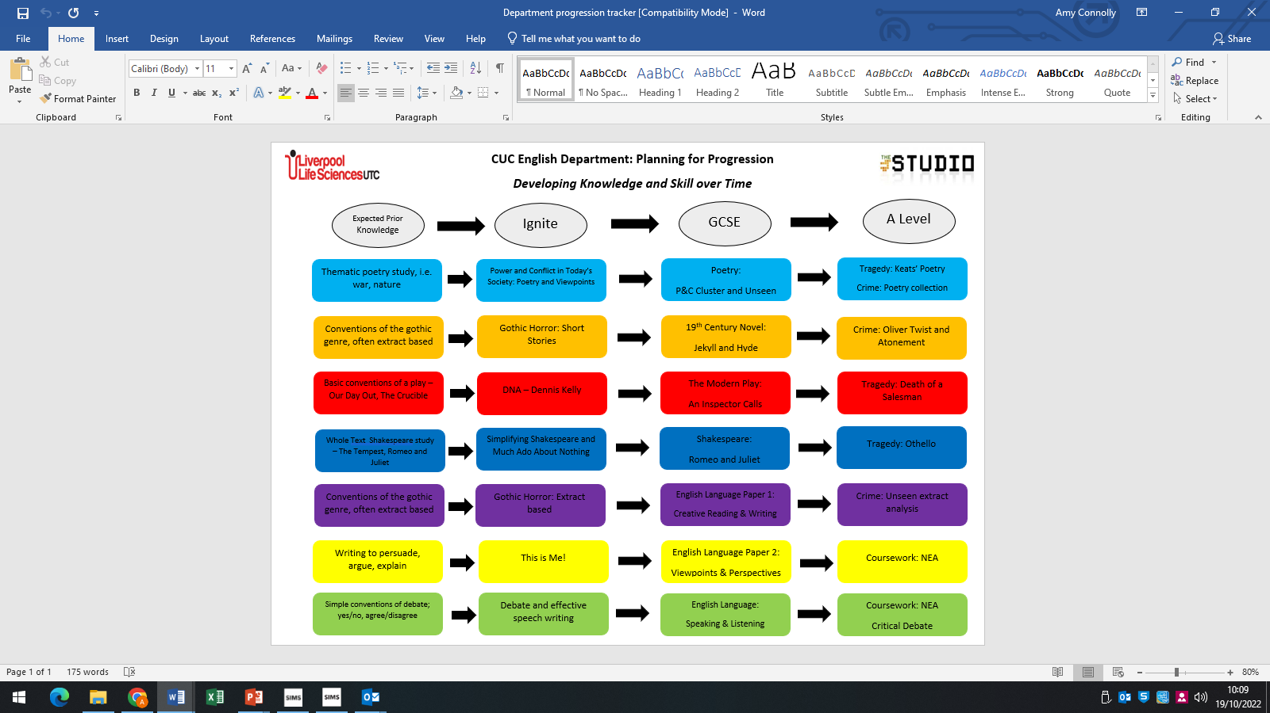

**Syllabus**

All students sit AQA GCSE Literature and Language at Key Stage 4.

There is a **Long-Term plan**, which provides the following key information:

* The aspects of the course to be studied during each module and whether it forms part of Literature or Language
* Assessment points and information
* Data cycle information and what will be used to inform the data

**Medium Term Plans** provide further, detailed information for each module including:

* Literacy focus for the week – Golden Triangle model
* Lesson breakdowns
* Weekly assessment and feedback

**Routines**

In English we follow the CUC model – Consolidate, Utilise, Challenge.

At Key Stage 4 students are provided with a consolidation task on the board which can include such things as short term and long-term recall tasks.

**Key Stage 4 Assessment Plan**

|  |  |  |
| --- | --- | --- |
| **PPE dates** | **Language** | **Literature** |
| 1. June   (Year 10) | Language Paper 2 – Full paper Section A and B using June 2020 | Literature Paper 2 – Full Paper using May 2018 |
| 1. November   (Year 11) | Language Paper 1 – Full Paper using May 2022 | Literature Paper 2 – Full Paper using June 2022 |
| 1. February   (Year 11) | Language Paper 2 – Full Paper using June 2022 | Literature Paper 1 – Full paper using June 2022 |

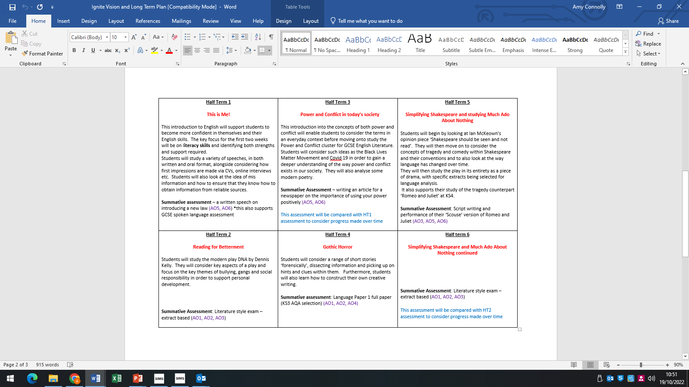

|  |  |  |  |  |
| --- | --- | --- | --- | --- |
| Year 10 | **Module 1: 19/09/22-04/11/22**  **The Natural World!**  Key aspects of course to be studied  **Literature** – P&C Cluster: The Prelude, Exposure and Storm on the Island  **Language** – Paper 2 Section A  Creative Writing  Assessment  **Mini**: Poetry – analysing The Prelude – focus on AO2  **Summative**: Creative writing – write a story about preparing for a natural disaster using SOTI for inspiration AO5, AO6  Key dates  DC1: Opens 06/10 Closes 12/10  Mini assessment w/c 26/09 to inform DC1 | **Module 2: 07/11/22-20/01/23**  **Power and Influence**  Key aspects of the course to be studied  **Literature** – An Inspector Calls  P&C Cluster: Ozymandias, London, My Last Duchess, Checking Out Me History  **Language** – Language Paper 1 Section A  Assessment  **Mini**: Language Paper 1 Q2  **Summative**: An Inspector Calls AO1, AO2,AO3  Key Dates  DC2: opens 08/12 closes 14/12  Summative assessment from module one to be used for Language DC2 and piece on AIC for lit | **Module 3: 23/01/23-05/05/23**  **Conflict! Physical and Internal**  Key aspects of course to be studied  **Literature** – Romeo and Juliet  P&C Cluster: The Charge of the Light Brigade, Bayonet Charge, Remains, War Photographer  **Language**: Viewpoint Writing – Societal and modern conflict  Assessment  **Mini**: Romeo and Juliet – analysing Act 1 Scene 1, key focus AO3  **Summative**: Power and Conflict – How is internal conflict presented in Remains and one other poem from the cluster?  Key Dates  DC3: opens 13/3 closes 17/3  Viewpoint writing work to be used for language DC3 and mini assessment for lit | **Module 4: 08/05/23 – 17/07/23**  **Reflecting, revising and NEA**  Key aspects of the course to be studied  Students will reflect on what they have learnt this year and consolidate. They will revise for their PPE and also complete their S&L assessment for **GCSE English Language**  Assessment  PPE 26/6 – 30/6  **Literature**: Paper 2 – Modern Texts and Poetry  **Language**: Paper 2 – Writer’s Viewpoints and Perspectives  Key dates  DC4: opens 26/06 closes 30/06  P&C assessment to be used for lit and NEA preparation for language |
| Year 11 | **Module 5: dates tbc**  **Transformations**  Key aspects of course to be studied  **Literature**: Dr Jekyll and Mr Hyde, Unseen Poetry with focus on change  **Language**: Paper 1 Section A using Mr Fisher extract  Assessment  **Mini**: Jekyll and Hyde with a key focus on AO1  **Summative**: Language Paper 1 Section A  Key dates  TBC | **Module 6: dates tbc**  **Identity**  Key aspects of the course to be studied  **Literature**: P&C Cluster – Poppies, Tissue, The Emigree, kamikaze  **Language**: Creative Writing: focus on feelings and emotions  Language Paper 2 Section A  Assessment  **Mini**: Language Paper 2 Q4  **Summative**: P&C assessment with key focus on comparison  Key dates  TBC | **Module 7: Reflecting and Revising**  Preparing for GCSE Exams |  |

**Career Progression and Next Steps**

The skills that students hone and develop in English will prove invaluable. They will work on essay writing skills, critical thinking skills and communication skills and so it marries with any further education course; it especially provides a solid foundation for any University Course.

Journalism and teaching are popular career paths for those who study English post GCSE.