Planning for Learning

Chemistry – Key Stage 5

Carly O'Neil

The Studio & Life Sciences UTC

Table of Contents

1.Sequencing Statement 1

2.Specialism Statement 1

3.Curriculum on a Page 2

4.Knowledge Acquisition and Routines 3

5.Literacy 4

6.Resources 4

8.Syllabus 5

9.What Will I Learn? 5

10.How Will I Be Assessed? 6

11.How Will This Prepare Me for My Next Steps? 7

12.Contribution to UTC & Studio Aims 7

13.Career Planning 8

# 1.Sequencing Statement

Carefully considered sequencing in A Level Chemistry is imperative as many of the topics covered build on and assume a significant volume of prior knowledge. There are 3 main branches of Chemistry in the syllabus, and the topics within these build over time. Furthermore the three main branches are not mutually exclusive, therefore it is not always possible to sequence in such a way as to always be able to assume prior knowledge. The long term plan for A Level Chemistry therefore seeks to sequence the content in the most effective order for supporting knowledge acquisition, but also be mindful of instances where a small amount of knowledge may be required but not yet fully understood.

Early in the first year of the course much of the prior knowledge is GCSE content, and in order to support knowledge acquisition resources are shared with the learners that allow them to refresh their knowledge prior to approaching the A level content. Additionally, there are examples of content that may not have been covered by all learners in their GCSE studies due to, for example, learners studying for the Combined Science qualification rather than Separate Science. In this instance the prior learning is not automatically assumed in order to ensure all learners build the foundations needed for in depth understanding of the content.

In year 2 of the course the foundations of each of the three main branches are built upon, and a good working knowledge and understanding of specific year 1 topics is necessary. In order to support learners a programme of revision of year 1 content has been incorporated in to the year 2 plan, and this has been sequenced to ensure the appropriate prior knowledge is timed to coincide with each year 2 topic. For example learners cannot approach the year 2 content of Thermodynamics without a good understanding of the Energetics content from year 1, so energetics is timed for revision slightly prior to approaching Thermodynamics.

# 2.Specialism Statement

The Chemistry team takes pride in demonstrating and encouraging a love of learning. The routines and programme we have in place encourage learners to take control over their own learning and develop an autonomous approach to their studies. We strive to provide an environment where the teaching is guided by the learning in order to ensure all learners progress in both their studies and their journey to becoming an effective independent learner.

# 3.Curriculum on a Page

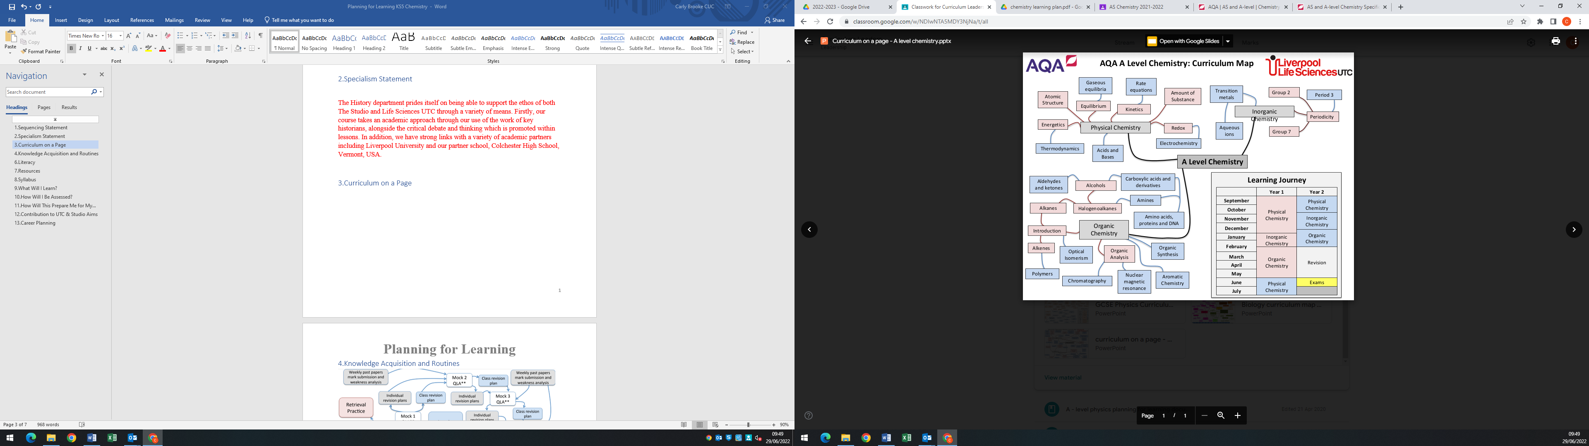

# 4.Knowledge Acquisition and Routines

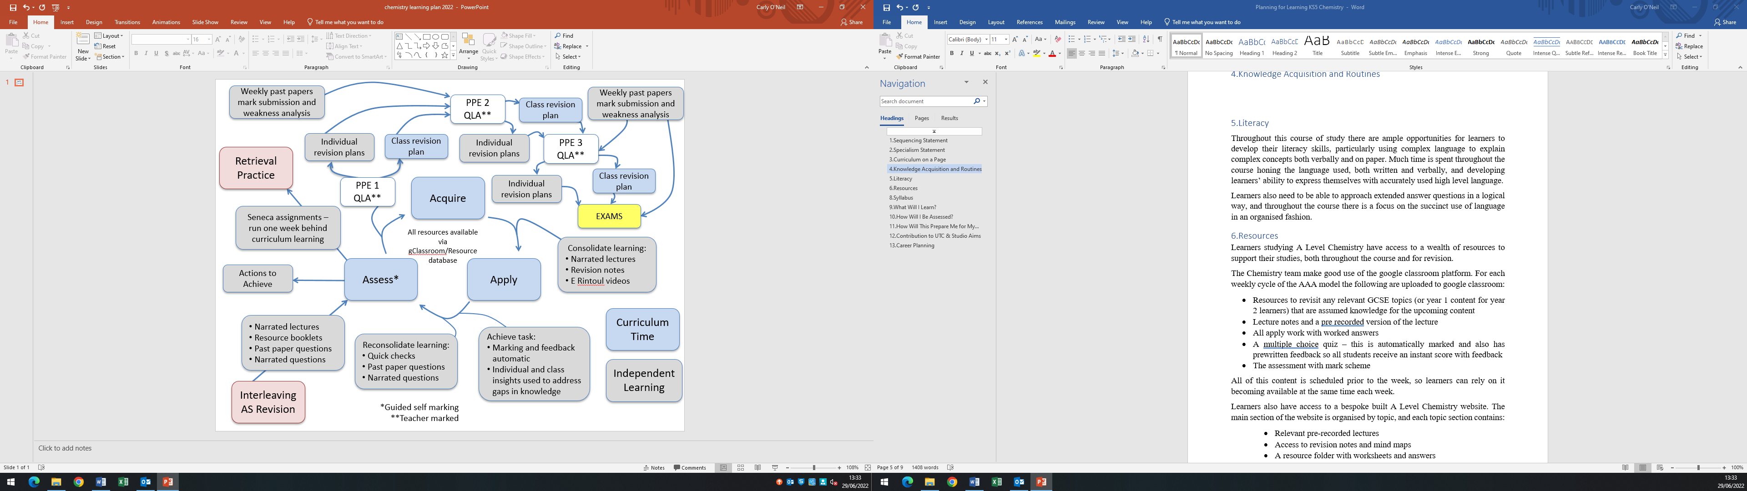

# 5.Literacy

Throughout this course of study there are ample opportunities for learners to develop their literacy skills, particularly using complex language to explain complex concepts both verbally and on paper. Much time is spent throughout the course honing the language used, both written and verbally, and developing learners’ ability to express themselves with accurately used high level language.

Learners also need to be able to approach extended answer questions in a logical way, and throughout the course there is a focus on the succinct use of language in an organised fashion.

There is a large amount specialist vocabulary throughout the course, and this year learners have struggled with words that are seemingly entirely new to them. In the upcoming academic year we will incorporate an increased focus on the morphology of words in Science as well as the etymology of some key words in order to try and improve the understanding and use of some of the complex language, and link it to previously acquired vocabulary.

# 6.Resources

Learners studying A Level Chemistry have access to a wealth of resources to support their studies, both throughout the course and for revision.

The Chemistry team make good use of the google classroom platform. For each weekly cycle of the AAA model the following are uploaded to google classroom:

* Resources to revisit any relevant GCSE topics (or year 1 content for year 2 learners) that are assumed knowledge for the upcoming content
* Lecture notes and a pre recorded version of the lecture
* All apply work with worked answers
* A multiple choice quiz – this is automatically marked and also has prewritten feedback so all students receive an instant score with feedback
* The assessment with mark scheme

All of this content is scheduled prior to the week, so learners can rely on it becoming available at the same time each week.

Learners also have access to a bespoke built A Level Chemistry website. The main section of the website is organised by topic, and each topic section contains:

* Relevant pre-recorded lectures
* Access to revision notes and mind maps
* A resource folder with worksheets and answers
* Any relevant video tutorials – many of these were made during the COVID-19 pandemic to support learners remotely, but have proven very useful since then as they cover topics that were found challenging
* Any other useful videos from external sources

In addition to this the website has sections providing links to exam questions grouped by topic, full past papers, resources for revising required practical activities and links to other useful websites.

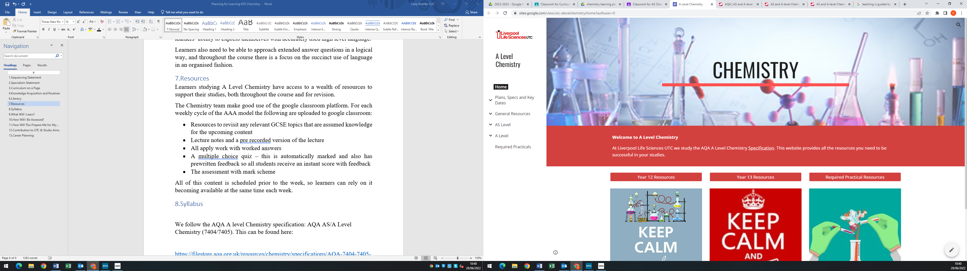

# 8.Syllabus

We follow the AQA A level Chemistry specification: AQA AS/A Level Chemistry (7404/7405). This can be found here:

<https://filestore.aqa.org.uk/resources/chemistry/specifications/AQA-7404-7405-SP-2015.PDF>

# 9.What Will I Learn?

There are 3 key branches of Chemistry; Organic, Inorganic and Physical. You will learn the fundamental principles of each of these in year 1, and build upon them in year 2. Organic Chemistry is essentially the chemistry of carbon compounds and their reactions, and these are the building blocks of life itself. Several careers apply an understanding of organic chemistry, such as doctors, veterinarians, dentists, pharmacologists, chemical engineers, and chemists.

Inorganic Chemistry is the study of compounds that are not organic, such as organometallic compounds and transition metal complexes. Inorganic compounds play key roles in catalysts, coatings, fuels, surfactants and drugs.

Physical Chemistry is the study of the physical structure of compounds, how they are bonded together and they how they interact with each other and other matter. It plays a key role in understanding the principles and phenomena in Chemistry, allowing us to manipulate chemical systems.

# 10.How Will I Be Assessed?

There are three exams at the end of the two years for A-level, all of which are two hours long. At least 15% of the marks for A-level Chemistry are based on what you learned in your practical activities. The AS has two exams at the end of the year. Both are 1 hour 30 minutes long.

**AS Assessment**

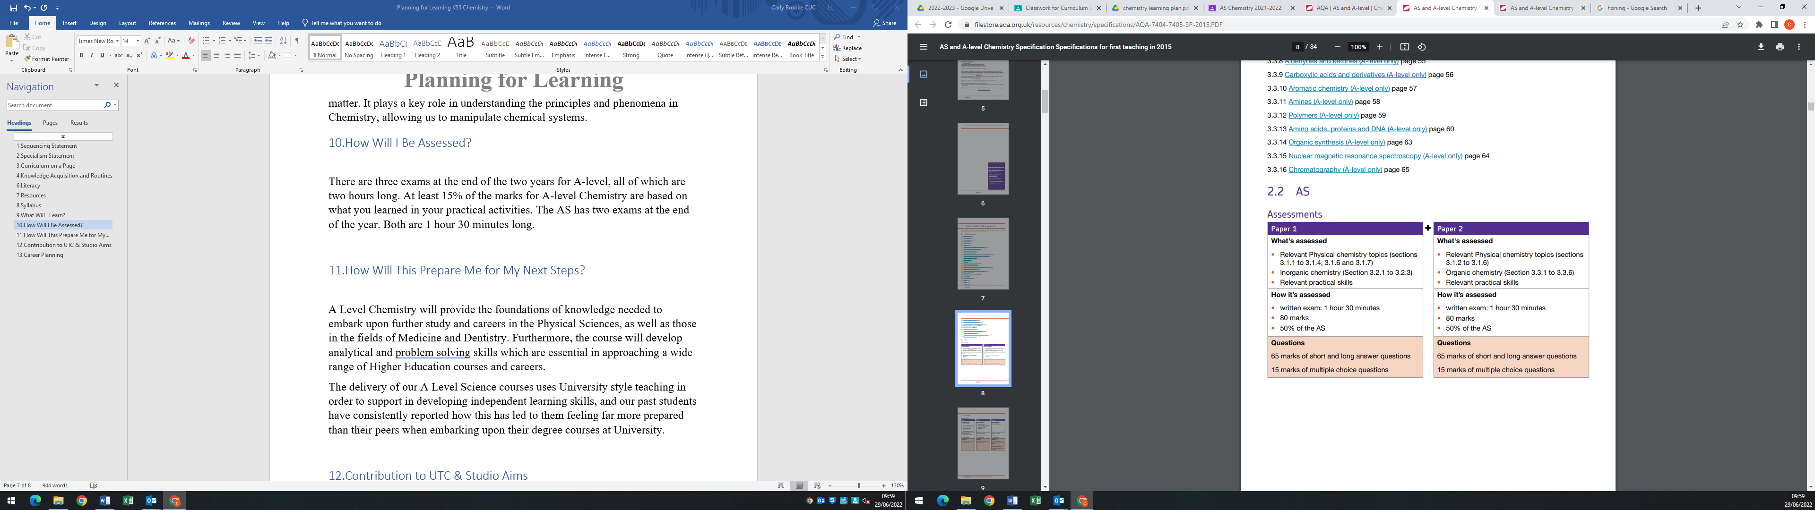

**A Level Assessment**

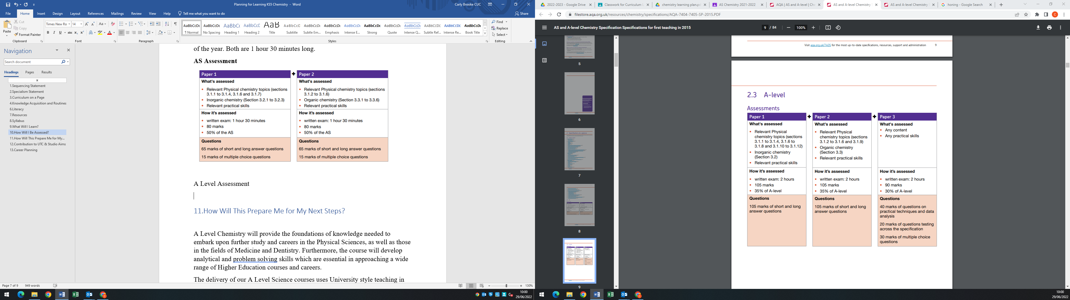

# 11.How Will This Prepare Me for My Next Steps?

A Level Chemistry will provide the foundations of knowledge needed to embark upon further study and careers in the Physical Sciences, as well as those in the fields of Medicine and Dentistry. Furthermore, the course will develop analytical and problem solving skills which are essential in approaching a wide range of Higher Education courses and careers.

The delivery of our A Level Science courses uses University style teaching in order to support in developing independent learning skills, and our past students have consistently reported how this has led to them feeling far more prepared than their peers when embarking upon their degree courses at University.

# 12.Contribution to UTC & Studio Aims

Chemistry develops the critical thought processes needed to understand and challenge complex ideas, and apply them to contexts that are both familiar and abstract. Our delivery of Key Stage 5 Science aims to provide a unique educational experience that delivers both theory and practice to the highest possible standards. By combining scientific skills with rigorous theoretical study, we aim to allow students to exceed expectations in lessons that are innovative, stimulating and exciting, leading them to successful careers and life experiences.

We have utilised an innovated model for delivering A Level subjects called the Triple A Model – Acquire, Apply, Asses. This model is designed to promote a love of learning, as well as incorporate pedagogical approaches that reflect current research in the Science of Learning. The routines and structures in place will support students into becoming effective independent learners, which also supports them towards success in futures studies in Higher Education.

# 13.Career Planning

According to bestcourse4me.com, the top five degree courses taken by students who have an A-

level in Chemistry are:

* Chemistry
* Biology
* Pre-clinical medicine
* Mathematics
* Pharmacology

Studying an A-level Chemistry related degree at university gives you all sorts of exciting career options, including:

* Analytical chemist
* Chemical engineer
* Clinical biochemist
* Pharmacologist
* Doctor
* Research scientist (physical sciences)
* Toxicologist
* Chartered certified accountant
* Environmental consultant
* Higher education lecturer
* Patent attorney
* Science writer
* Secondary school teacher