

**English Department**

**Planning for Learning Document**

Staff Members:

Amy Connolly – Curriculum Lead

Andrew Mackenzie – Literacy Lead for English

Astra Halliday – Classroom Teacher

Oliver Denholm – Classroom Teacher

Lucy Henderson – KS5 English Lead

Jack Hadden - ECT

**Statement of Intent**

*‘The ability to read, write, and analyse; the confidence to stand up and demand justice and equality; the qualifications and connections to get your foot in the door and take your seat at the table – all of that starts with education’* Michelle Obama

Our English Curriculum empowers students to access and successfully engage in the ever-changing world that we live in. By instilling the skills to become **Confident Orators**, **Eloquent Writers**, **Inquisitive Readers** and **Empathetic Thinkers**, our students will be pioneers in their communities.

At Key Stage 5 we offer A Level Literature. Students will study a variety of texts through the genre of Tragedy and Crime. Students will enhance their reading, writing and Oracy skills at this level by critically analysing texts through different lenses, such as Marxism, Feminism and Post-Colonialism. Students also produce two pieces of coursework that enable them to express their own ideas, whilst also exploring the perspectives of esteemed critics to encourage a nuanced evaluation.

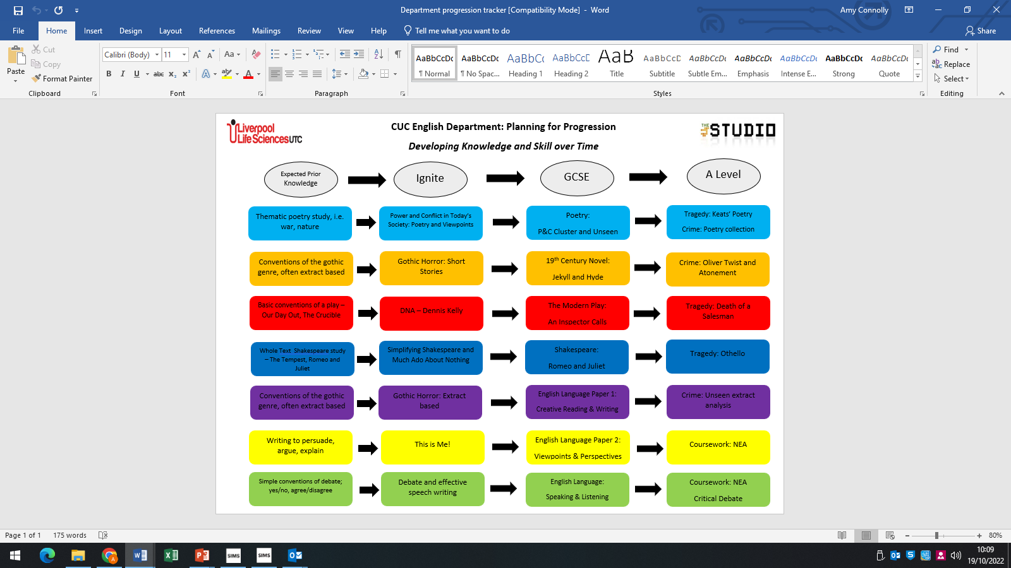

**Syllabus**

At Key Stage 5 we offer AQA English Literature B; Tragedy and Crime.

There is a **Long-Term plan**, which provides the following key information:

* The aspects of the course to be studied during each module and whether it forms part of Literature or Language
* Assessment points and information
* Data cycle information and what will be used to inform the data

**Medium Term Plans** provide further, detailed information for each module including:

* Literacy focus for the week – Golden Triangle model
* Lesson breakdowns
* Weekly assessment and feedback

**Routines**

In English we follow the CUC model – Consolidate, Utilise, Challenge.

At Key Stage 4 and 5, students are provided with a consolidation task on the board which can include such things as short term and long-term recall tasks.

**Key Stage 5 Assessment Plan**

|  |  |  |
| --- | --- | --- |
| **PPE dates** | **Tragedy** | **Crime** |
| 1. June (Year 12) | Section A and B – Othello using November 2020 | Section A and C – Unseen Crime and two crime texts  June 2019 & June 2018 |
| 1. November (Year 13) | Full Paper using June 2019 | Full Paper using November 2020 |
| 1. February (Year 13) | Full Paper using June 2022 | Full Paper using June 2022 |

**Career Progression and Next Steps**

The skills that students hone and develop in English will prove invaluable. They will work on essay writing skills, critical thinking skills and communication skills and so it marries with any further education course; it especially provides a solid foundation for any University Course.

Journalism and teaching are popular career paths for those who study English post GCSE.