

Planning for Learning

A Level Psychology (AQA) – Key Stage 5

The Studio & Life Sciences UTC

**Contents**

1. Strategy Statement
2. Sequencing Statement
3. Knowledge Acquisition/Routines
4. Literacy
5. Resources
6. Subject
7. Syllabus
8. What will I learn?
9. How will I be assessed?
10. How will this prepare me for next steps?
11. Contribution to UTC and Studio aims
12. Career planning

## Strategy Statement

**A Level Psychology Curriculum Overview**

The Psychology department is committed to the school’s motto ‘Every day is an Interview’, by providing a professional curriculum with breadth that allows all of our students to be equipped with the core knowledge that is the foundation of success in the dynamic world of psychology. We aim to maximise their cognitive development, to develop the whole person and the talents of the individual so that Liverpool Life Science UTC students become active and economically self-sufficient members of the community. The A Level psychology curriculum equips students with the skills they need to successfully access university at the end of year 13.

**Intent**

The intent of the A Level Psychology Curriculum is to prepare students for life beyond Liverpool Life Sciences UTC, whether that be in further education, employment or apprenticeships. The curriculum has been designed to challenge, motivate and inspire students to life-long learning.

**Studying A Level Psychology at Liverpool Life Sciences, students learn to:**

* know and understand psychological concepts, terminology, objectives, the integrated nature of psychology in the real world and the impact of psychology on individuals, the wider society and across cultures.
* apply knowledge and understanding of psychological research and theories across topics in psychology.
* develop ability to write effectively through extended writing enhancing their analytical skills.
* develop as effective and independent students, and as critical and reflective thinkers with enquiring minds.
* understand research methods and be able to apply this knowledge across the subject to be able to evaluate and analyse research in an effective way.
* develop and apply ability to interpret and analyse data including statistical Inferential testing, drawing relevant conclusions.



**Implementation**

The course is fragmented into specific units and each topic contains a discrete body of knowledge and, at the end of each topic, knowledge is tested through formal written assessments. The curriculum is delivered through the ‘AAA’ teaching and assessment model.

* **Acquire** – students acquire the relevant knowledge in class and are responsible for making their own notes to act as their revision – students are guided and shown how to reduce information to ensure learning takes place.
* **Apply** – students apply their knowledge through homework tasks and through some in class assessments/activities to ensure content taught through the acquire lesson has been understood. A Level students are expected to apply their learning independently out with lesson time.
* **Assess** – the final stage of the process is where students are assessed each week on what they have previously learned in the topic. Students follow the YET feedback process to identify the gaps in their knowledge and they then use the mark schemes to fill their gaps. Feedback is detailed and allows for stretch and challenge as well as additional support where needed.

**In every lesson students can expect the following:**

* High expectations of the classroom teacher
* Fast retrieval practice at the beginning of lessons to support learning
* Re-teaching where misconceptions or errors have been identified.
* Study skills embedded in the context of subjects across the curriculum.
* Lesson posted on gClassroom after each lesson has been delivered to allow students to revisit content and prepare for their assess lesson.

**Students will receive:**

* A 5-minute retrieval practice at the start of every lesson – Connect 4
* An oracy task every lesson to improve the quality of verbal responses.
* A no hands up policy to allow ‘thinking time’ for all
* Cumulative assessments at the end of each topic to improve opportunities for retrieval practice on topics previously learned.
* Lead learner status in class if showing potential of being a A-A* grade student. The Lead Learners will support other learners in class, mark student responses using mark schemes and even teach small groups.
* Support if students are struggling in the subject by being provided with structure strips to improve the quality of extended writing, and each student failing to achieve a D in year 12 and a C in year 13 in topic tests will have re-sit opportunities allowing students more time to revise and prepare for their exam. Additional and parental support is requested if students at this stage are continuing to struggle in psychology to ensure the student has every opportunity to be fully supported.

**Impact**

The impact of the Psychology department’s curriculum is measured through several means:

* Outcomes for students at A level in Y13.
* Value Added
* Progress and attainment data for current year groups at each data cycle.
* Destinations data
* Love of the subject and potential career path

**Challenges:**

* First teaching of subject for students – new subject terminology – no prior learning
* Differentiated approach to teaching and learning essential to ensure all students are challenged yet supported in their progress.

**How to secure and improve outcomes this year**

* Focus on key groups of students SEN, EAL, Boys V girls, high ability to address trends in data
* Improved policy on literacy to ensure students learn and use subject specific terminology in both their written and verbal responses.
* Oracy task in every lesson to improve students’ verbal responses and use of academic vocabulary.
* Regular retrieval practice opportunities for students in every lesson to improve recall – connect 4 activity.
* Improved routines to ensure social science classrooms are conducive learning spaces for all students.
* Weekly homework assignments to allow students to get used to working independently and managing their time to meet deadlines.

# Sequencing Statement

The Psychology curriculum begins with the Paper 2 Approaches topic. This topic allows the students to grasp a good foundation knowledge of the different approaches in psychology which enables them to develop an understanding of the various perspectives within the subject. Students having the opportunity to understand the biological approach and treatments along with the humanistic approach and treatments, for example, allows students to understand the complexity of psychology as a whole. This topic is also essential as it enables students to learn about the origins of psychology and the paradigm shifts over time, for example, the move from the behaviourist and psychodynamic approaches in the 1930’s to the cognitive approach in the 1970’s.

Armed with this essential foundation knowledge students can focus on developing their understanding of other topics in paper 2 followed by the four topics in paper 1 which they will study in Year 12. All paper 1 and 2 A Level content will be covered in year 1. The social influence topic is delivered in the last half term to tie in with the annual trip to Auschwitz, Poland. This is a fantastic opportunity which gives students the chance to see the devastating impact of social influence in the real world. This allows Y12 to sit a full paper 1 and 2 PPE at the end of their first year and again in November of year 2.

In year 2 students begin the year learning about the various issues and debates in psychology. This topic ties in closely with the approaches topic and there are opportunities for students to revisit approaches throughout this topic. This topic enables psychology students to enhance their evaluations using key issues and debates which enables them to secure level 4 answers in essays. The remainder of year 2 is where students select their optional topics which include relationships, schizophrenia and aggression. The optional topics have been carefully selected based on previous outcomes for students, taking into account where students have performed best across the country. Students will finish their learning prior to February half term with further research methods where they will learn inferential testing.

After February half term students will sit final PPE’s covering paper 1 , 2 and 3. This allows them, for the first time, to receive an overall mark across all three papers. The remainder of the academic year students will receive a detail run in plan to their exams where revision in carefully planned and structured to allow for hard thinking and retrieval practice along with exam skill preparation.

# Knowledge Acquisition/Routines

**Entering**

* Welcome students at the door as they enter the room
* Assign roles to students to give books/folders out/ board pens/ wipes etc – there should be set areas for each classes books and folders in the classroom.
* Connect 4 activity should be on the board – students engage in starter activity quickly (desk work)
* Teacher ensures register is taken during the starter task.

**Department Expectations in class**

* Students should be reminded outside coats should be off in class (KS4 and 5)
* Mobile phones should be away (should not be used in class for note taking or taking pictures of the board).
* Toilets (adhere to school policy)
* No hands up approach to questioning– this ensures students are always prepared to answer questions. This should be done in a supportive environment where students are helped to fill in gaps in their knowledge if they are unsure of the answer.
* Everyone in the room has the right to be respected – when one person is talking in the room we listen – this includes the teacher.
* If a student arrives late to lessons the teacher must address this and ensure there is a consequence for lateness to class – where necessary parents/heads of year/tutors should be informed.
* Departmental praise postcards should be sent home to parents regularly.

**Exit**

* Students should take responsibility to tidy up (assign roles to students – collect books, folders, pens).
* HW assignment reminder
* Students should stand behind desks (KS4)
* Dismissed row by row (KS4)

**Homework/Feedback Policy**

All homework assignments must be posted as assignments on google classroom so that students get used to this way of work across the department. Students do have the option to write their assignments and upload pictures if they have limited/no access to a computer at home.

High expectations on meeting deadlines across all social science subjects at both KS4 and 5. Students failing to meet deadlines it is essential parents are informed in the first instance and if it is a recurring problem then the teacher must find time to detain the students to ensure work is complete.

**KS4** students should be placed on a Performance Contract (communicated with parents, Head of Year, Head of department and Form Tutor) and filed in the department folder if they keep missing deadlines. If no improvement made in 2 weeks inform HOD for further action.

**KS5** students should be placed on a Actions to Achieve (communicated with parents, tutor. HOD and the sixth form team) if they keep missing deadlines (filed in department folder). If no improvement made in 2 weeks inform HOD and sixth form team for further action.

Students should receive feedback on their assignments/in class assessments within a two-week period. This can be done using self-assessment (with teacher guidance), peer assessment (with teacher guidance) or teacher assessment. Consider how your feedback will impact the students’ progress.

For **summative assessments** students should receive a YET Feedback sheet and a mark scheme and time should be taken in these lessons to ensure students understand where they went right/wrong and given the opportunity to fill gaps in their knowledge. In Y12 if students achieve below a D grade they should have a resit opportunity and if no improvement placed on an A2A. In Y13 if students achieve below a C grade they should have a resit opportunity and if no improvement placed on an A2A.

Teacher marking – red pen

Student gap filling/self-marking/peer marking – green pen

**Summative assessments** should be kept in student’s assessment folder with a tracker document at the back so that students can track their own progress over time.

At KS4 and 5 there should be a minimum of one assignment per week set as homework.

**Triple A Model**

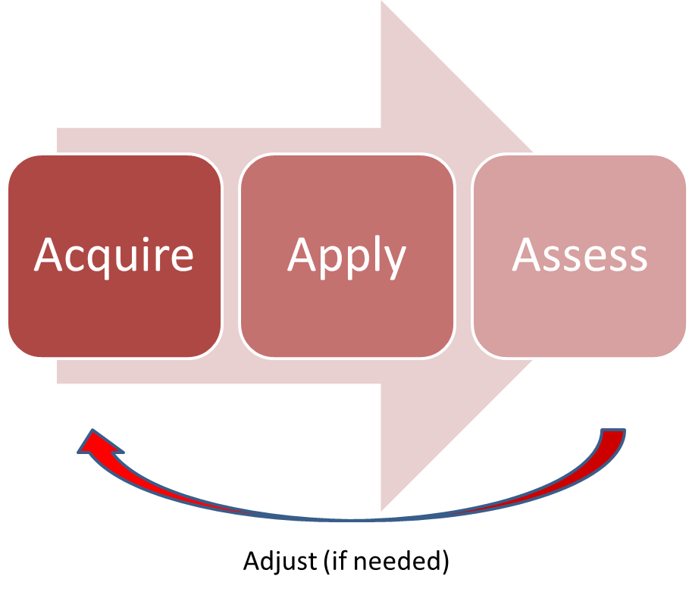

All Social Science Lessons should be designed around the triple A model. Teachers can choose how they do this either in lessons (Acquire, Apply, Assess) or through lesson and homework tasks (Acquire in lessons, apply, assess as homework). This ensures regular testing to check student learning and progress. It is essential we give students lots of opportunities for ‘hard thinking time’. There are elements within every lesson that will incorporate acquire, apply and assess. For example, in every social science lesson the starter activity is a connect 4 activity where student need to retrieve prior learning (what they learned last lessons, last week, last month, last year) so assess work is embedded into every lesson. Students will also have an oracy task in every lesson which will target the apply element of this model. Can students articulate their response to questions verbally using key subject specific terminology?

**Class Books – KS4**

Class books should be used for notes and task work. This is where formative assessment of student learning takes place. The same marking and feedback policy (as above) stands for class books. All tasks in book must be marked by either self (with teacher guidance), peers (with teacher guidance) or the class teacher.

All class books must have the **subject specific command words on the first inside page** and students should keep a **glossary of key terms at the back** of their books. Students should add to this this every time they are introduced to a new key term and teachers should follow the **golden triangle** when doing so – **definition, pronunciation, recognition**. All Social Science teachers should encourage students to learn key terms and use them in their verbal and written responses. High expectations of literacy at all times evident in books, assignments and lessons.

Teachers must ensure clear expectations around presentation and quality of work and ensure students take pride in their work, book and folder.

* Title and date (underlined with a ruler)
* Show high expectations of quality of written work
* Teacher should encourage proof reading of work and allow time for this
* Student checking for SPAG as well as teacher – evident in marking and feedback
* Use of academic language encourage consistently.

**KS5 – Notes/Assessment Folder**

At KS5 students are responsible for their own notes but each have an assessment folder where their summative assessments are stored. At the back of their folders there is a tracking document so students can track their own progress over time. Further evidence of progress/feedback can be found on google classroom with their assignment feedback.

**Teaching Pack**

By end of week 1 all Social Science staff must have a teaching pack completed for their classes and this should be easily accessible of the teacher’s desk. This should be a working document and used to help plan lessons to cater for the needs of all students in the class. Evidence of gain plan actions should be found in students’ books and assignments set on classroom. Use of departmental scaffold documents should be evidenced and signs that the scaffolds are slowly being removed to provide elements of challenge at a pace that is right for students.

**Curriculum/LTPs**

Your Long-term plans should reflect the journey the students are on in your course and there should be a rational for the sequencing of your LTP.

Alongside your LTP there should be curriculum plans for each topic which shows your medium-term planning – this should be kept in your teaching pack and annotated to show changes based on student pace and learning.

**Trackers**

Within your subject folder on the shared area there should be a folder for 2022-23 trackers where your trackers should be kept. Trackers must be detailed showing all summative assessments, dates, mark out of, % and grades (indicate grade boundaries used) and colour coded against target grade.

**Gain Plans**

Gain plans must be updated every data cycle to show reflection and adaptations to the interventions you have in place for each student. If a student has made no progress from one data cycle to the next a different intervention strategy should be used. Gain plans should be stored in the departmental shared area.

# Literacy

**Tier 1**: Basic familiar words commonly used by most students

**Tier 2**: Robust, high frequency words that students encounter across the content area and topics – often have multiple meanings. Command words.

**Tier 3:** Low frequency words that are content specific

Tier 1, 2 and 3 words will be displayed in each classroom and planning should reflect how teachers are integrating the words into their lessons and delivery to enhance student’s vocabulary.

**Glossary of key terms**

At KS4 we are introducing a glossary of key terms at the back of class books. Each time a new word is introduced to the students they add the word and definition to their glossary. Teacher should deliver using the golden triangle – definition, pronunciation, recognition.

**Command Words**

Command words can be found at the front of student books – when students are confronted with an exam question they should use their command work sheet to ensure they fully understand what the question in this subject is asking them. This should be link to the assessment objectives in the subject. For example, students in psychology should know that describe = A01 and evaluate = A03 as this will help them to understand how to structure their responses to exam questions to secure the highest available marks.

**Quality of written responses:**

* High expectations
* Students encourage to proof read their work
* Students and teachers check SPAG
* Use of academic language in written responses (teacher highlighting to student improved subject specific replacement words).

**Reading/Film Posters**

Students in social science subjects are encouraged to engage in wider reading to allow them to understand with wider aspects of the subjects they are studying or if there is something specific a student is interested in learning more about they have the opportunity to learn more about the topic. This allows for ‘reading for betterment’ (literacy policy).

**Social Science Little Library**

We have created a social science little library where students have the opportunity to take a book home to read that will expand and enhance their knowledge of key aspects of the subject they are studying. This follows a bring a book, take a book approach.

**Classroom Talk**

In every KS4 and 5 lessons students have a **connect 4** starter activity which will help them grapple with key terms and revisit them regularly to embed learning and understanding. Students will also have an **oracy task** every lesson encourage them to articulate high quality verbal responses using subject specific terminology.

# Resources

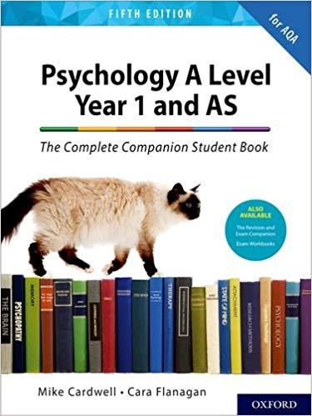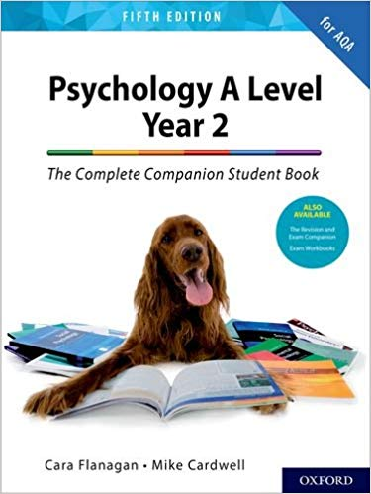

# Subject

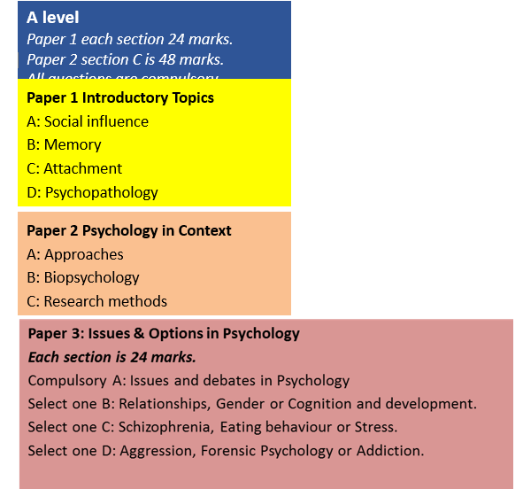

# Syllabus

AQA

# What Will I Learn?

**Year 1: September – December – Paper 2**

**Psychology in Context**

Students will be expected to:

* demonstrate knowledge and understanding of psychological concepts, theories, research studies, research methods and ethical issues in relation to the specified Paper 2 content
* apply psychological knowledge and understanding of the specified Paper 2 content in a range of contexts
* analyse, interpret and evaluate psychological concepts, theories, research studies and research methods in relation to the specified Paper 2 content
* evaluate therapies and treatments including in terms of their appropriateness and effectiveness.
* Knowledge and understanding of research methods, practical research skills and mathematical skills

These skills should be developed through study of the specification content and through ethical practical research activities, involving:

* designing research
* conducting research
* analysing and interpreting data.

In carrying out practical research activities, students will manage associated risks and use information and communication technology (ICT).

**Approaches in psychology**

Origins of psychology: Wundt, introspection and the emergence of psychology as a science.

The basic assumptions of the following approaches:

* Learning approaches: the behaviourist approach, including classical conditioning and Pavlov’s research, operant conditioning, types of reinforcement and Skinner’s research; social learning theory including imitation, identification, modelling, vicarious reinforcement, the role of mediational processes and Bandura’s research.
* The cognitive approach: the study of internal mental processes, the role of schema, the use of theoretical and computer models to explain and make inferences about mental processes. The emergence of cognitive neuroscience.
* The biological approach: the influence of genes, biological structures and neurochemistry on behaviour. Genotype and phenotype, genetic basis of behaviour, evolution and behaviour.
* The psychodynamic approach: the role of the unconscious, the structure of personality, that is ID, ego and superego, defence mechanisms including repression, denial and displacement, psychosexual stages.
* Humanistic psychology: free will, self-actualisation and Maslow’s hierarchy of needs, focus on the self, congruence, the role of conditions of worth. The influence on counselling psychology.
* Comparison of approaches.

**Biopsychology**

* The divisions of the nervous system: central and peripheral (somatic and autonomic).
* The structure and function of sensory, relay and motor neurons. The process of synaptic transmission, including reference to neurotransmitters, excitation and inhibition.
* The function of the endocrine system: glands and hormones.
* The fight or flight response including the role of adrenaline.
* Localisation of function in the brain and hemispheric lateralisation: motor, somatosensory, visual auditory and language centres; Broca’s and Wernicke’s areas, split brain research. Plasticity and functional recovery of the brain after trauma.
* Ways of studying the brain: scanning techniques, including functional magnetic resonance imaging (fMRI); electroencephalogram (EEGs) and event-related potentials (ERPs); post-mortem examinations.
* Biological rhythms: circadian, infradian and ultradian and the difference between these rhythms. The effect of endogenous pacemakers and exogenous zeitgebers on the sleep/wake cycle.

**Research methods**

Students should demonstrate knowledge and understanding of the following research methods, scientific processes and techniques of data handling and analysis, be familiar with their use and be aware of their strengths and limitations.

* Experimental method. Types of experiment, laboratory and field experiments; natural and quasiexperiments.
* Observational techniques. Types of observation: naturalistic and controlled observation; covert and overt observation; participant and non-participant observation.
* Self-report techniques. Questionnaires; interviews, structured and unstructured.
* Correlations. Analysis of the relationship between co-variables. The difference between correlations and experiments.
* Content analysis.
* Case studies.

**Year 1: December - June – Paper 1**

**Introductory topics in psychology**

Students will be expected to:

* demonstrate knowledge and understanding of psychological concepts, theories, research studies, research methods and ethical issues in relation to the specified Paper 1 content
* apply psychological knowledge and understanding of the specified Paper 1 content in a range of contexts
* analyse, interpret and evaluate psychological concepts, theories, research studies and research methods in relation to the specified Paper 1 content
* evaluate therapies and treatments including in terms of their appropriateness and effectiveness.

Knowledge and understanding of research methods, practical research skills and mathematical skills

1. These skills should be developed through study of the specification content and through ethical

practical research activities, involving:

* designing research
* conducting research
* analysing and interpreting data.

In carrying out practical research activities, students will manage associated risks and use information and communication technology (ICT).

**Social influence**

* Types of conformity: internalisation, identification and compliance. Explanations for conformity: informational social influence and normative social influence, and variables affecting conformity including group size, unanimity and task difficulty as investigated by Asch.
* Conformity to social roles as investigated by Zimbardo.
* Explanations for obedience: agentic state and legitimacy of authority, and situational variables affecting obedience including proximity, location and uniform, as investigated by Milgram.

Dispositional explanation for obedience: the Authoritarian Personality.

* Explanations of resistance to social influence, including social support and locus of control.
* Minority influence including reference to consistency, commitment and flexibility.
* The role of social influence processes in social change.

**Memory**

* The multi-store model of memory: sensory register, short-term memory and long-term memory.

Features of each store: coding, capacity and duration.

* Types of long-term memory: episodic, semantic, procedural.
* The working memory model: central executive, phonological loop, visuo-spatial sketchpad and episodic buffer. Features of the model: coding and capacity.
* Explanations for forgetting: proactive and retroactive interference and retrieval failure due to absence of cues.
* Factors affecting the accuracy of eyewitness testimony: misleading information, including leading questions and post-event discussion; anxiety.
* Improving the accuracy of eyewitness testimony, including the use of the cognitive interview.

**Attachment**

* Caregiver-infant interactions in humans: reciprocity and interactional synchrony. Stages of attachment identified by Schaffer. Multiple attachments and the role of the father.
* Animal studies of attachment: Lorenz and Harlow.
* Explanations of attachment: learning theory and Bowlby’s monotropic theory. The concepts of a critical period and an internal working model.
* Ainsworth’s ‘Strange Situation’. Types of attachment: secure, insecure-avoidant and insecure resistant.

Cultural variations in attachment, including van Ijzendoorn.

* Bowlby’s theory of maternal deprivation. Romanian orphan studies: effects of institutionalisation.
* The influence of early attachment on childhood and adult relationships, including the role of an internal working model.

**Psychopathology**

* Definitions of abnormality, including deviation from social norms, failure to function adequately, statistical infrequency and deviation from ideal mental health.
* The behavioural, emotional and cognitive characteristics of phobias, depression and obsessive compulsive disorder (OCD).
* The behavioural approach to explaining and treating phobias: the two-process model, including classical and operant conditioning; systematic desensitisation, including relaxation and use of hierarchy; flooding.
* The cognitive approach to explaining and treating depression: Beck’s negative triad and Ellis’s ABC model; cognitive behaviour therapy (CBT), including challenging irrational thoughts.
* The biological approach to explaining and treating OCD: genetic and neural explanations; drug therapy.

**Year 2: September - February – Paper 3**

**Issues and options in psychology**

Students will be expected to:

* demonstrate knowledge and understanding of psychological concepts, theories, research studies, research methods and ethical issues in relation to the specified Paper 3 content
* apply psychological knowledge and understanding of the specified Paper 3 content in a range of contexts
* analyse, interpret and evaluate psychological concepts, theories, research studies and research methods in relation to the specified Paper 3 content
* evaluate therapies and treatments including in terms of their appropriateness and effectiveness.

Knowledge and understanding of research methods, practical research skills and mathematical skills

These skills should be developed through study of the specification content and through ethical practical research activities, involving:

* designing research
* conducting research
* analysing and interpreting data.

In answering questions on Issues and debates in psychology students will be expected to illustrate their answers with knowledge and understanding of topics studied elsewhere in the specification as appropriate.

In carrying out practical research activities, students will manage associated risks and use information and communication technology (ICT).

**Issues and debates in psychology**

* Gender and culture in psychology – universality and bias. Gender bias including androcentrism and alpha and beta bias; cultural bias, including ethnocentrism and cultural relativism.
* Free will and determinism: hard determinism and soft determinism; biological, environmental and psychic determinism. The scientific emphasis on causal explanations.
* The nature-nurture debate: the relative importance of heredity and environment in determining behaviour; the interactionist approach.
* Holism and reductionism: levels of explanation in psychology. Biological reductionism and environmental (stimulus-response) reductionism
* Idiographic and nomothetic approaches to psychological investigation.
* Ethical implications of research studies and theory, including reference to social sensitivity.

**Relationships**

* The evolutionary explanations for partner preferences, including the relationship between sexual selection and human reproductive behaviour.
* Factors affecting attraction in romantic relationships: self-disclosure; physical attractiveness, including the matching hypothesis; filter theory, including social demography, similarity in attitudes and complementarity.
* Theories of romantic relationships: social exchange theory, equity theory and Rusbult’s investment model of commitment, satisfaction, comparison with alternatives and investment. Duck’s phase model of relationship breakdown: intra-psychic, dyadic, social and grave dressing phases.
* Virtual relationships in social media: self-disclosure in virtual relationships; effects of absence of gating on the nature of virtual relationships.
* Parasocial relationships: levels of parasocial relationships, the absorption addiction model and the attachment theory explanation.

**Schizophrenia**

* Classification of schizophrenia. Positive symptoms of schizophrenia, including hallucinations and delusions. Negative symptoms of schizophrenia, including speech poverty and avolition. Reliability and validity in diagnosis and classification of schizophrenia, including reference to co-morbidity, culture and gender bias and symptom overlap.
* Biological explanations for schizophrenia: genetics, the dopamine hypothesis and neural correlates.
* Psychological explanations for schizophrenia: family dysfunction and cognitive explanations, including dysfunctional thought processing. Drug therapy: typical and atypical antipsychotics.
* Cognitive behaviour therapy and family therapy as used in the treatment of schizophrenia. Token economies as used in the management of schizophrenia.
* The importance of an interactionist approach in explaining and treating schizophrenia; the diathesis stress model.

**Aggression**

* Neural and hormonal mechanisms in aggression, including the roles of the limbic system, serotonin and testosterone. Genetic factors in aggression, including the MAOA gene.
* The ethological explanation of aggression, including reference to innate releasing mechanisms and fixed action patterns. Evolutionary explanations of human aggression.
* Social psychological explanations of human aggression, including the frustration-aggression hypothesis, social learning theory as applied to human aggression, and de-individuation. Institutional aggression in the context of prisons: dispositional and situational explanations. Media influences on aggression, including the effects of computer games. The role of desensitisation, disinhibition and cognitive priming.

# How Will I Be Assessed?

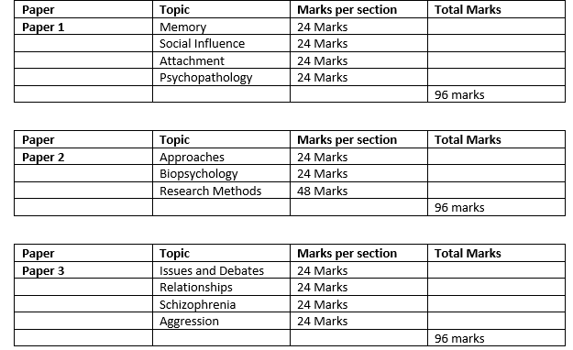

**Year 1:**

* **Paper 2 PPE January: Paper 1 and Paper 2 PPE: June**
* **End of topic tests for each topic –** Each time you complete a topic you will receive a 48 mark assessment on that topic – this may also contain research methods questions and questions from topics previously covered. You must be achieving a D+ in these assessments minimum in year 1 and a C+ minimum is year 2. Your results will also be carefully tracked against your target grade. Those achieving less than minimum expectation will have a resit opportunity and be placed on an Actions to Achieve to monitor improvement/progress closely.

**Year 2:**

* **End of topic tests for each topic –** Each time you complete a topic you will receive a 48 mark assessment on that topic – this may also contain research methods questions and questions from topics previously covered. You must be achieving a D+ in these assessments minimum in year 1 and a C+ minimum is year 2. Your results will also be carefully tracked against your target grade. Those achieving less than minimum expectation will have a resit opportunity and be placed on an Actions to Achieve to monitor improvement/progress closely.
* **Paper 1 and Paper 2 PPE: November**
* **Paper 1, 2 and 3 PPE: February**

**Assessment objectives**

Assessment objectives (AOs) are set by Ofqual and are the same across all AS and A-level Psychology specifications and all exam boards.

The exams will measure how students have achieved the following assessment objectives.

**AO1**: Demonstrate knowledge and understanding of scientific ideas, processes, techniques and procedures.

**AO2:** Apply knowledge and understanding of scientific ideas, processes, techniques and procedures:

* in a theoretical context
* in a practical context
* when handling qualitative data
* when handling quantitative data.

**AO3**: Analyse, interpret and evaluate scientific information, ideas and evidence, including in relation to issues, to:

# How Will This Prepare Me For My Next Steps?

A Level Psychology is the study of human behaviour and thinking and this qualification prepares students for their next steps after A Levels in a number of different ways. It allows students to understand research and how research evidence can be applied in the real world to improve the quality of life, particularly those who are suffering. Students develop their analytical thinking and learn how research can be evaluated highlighting the strengths and limitations. The study of research methods provides students with a good foundation that will support their studies at degree Level, not only in psychology, but in a number of different subject areas. Many of the topics taught at A Level are also found at degree level, therefore provides A Level students with the foundation knowledge and skills needed to go on and study the subject in more depth at degree Level and beyond.

# Contribution to UTC & Studio Aims

Throughout the A Level course students will have opportunities to attend trips where they can enhance their learning experience and see psychology in the real world and the impact the subject has had and can have in the future. Our annual Auschwitz trip allows students to the opportunity to understand the social influence topic much more effectively than they could do in the classroom. Students also have the opportunity to hear from industry experts in our masterclass events. There are so many branches of psychology we feel it is important for our students to understand as many branches as possible to guide them towards careers they may be interested in entering into in the future. This includes talks from clinical psychologists, educational psychologists, therapists and forensic psychologists. We run a Wellbeing App project with Professor Peter Kinderman from Liverpool University (former president of the British Psychological Society) which allows students to study the newest branch of psychology, positive psychology enabling the students to learn about the scientific study of what makes life worth living.

# Career Planning

**Jobs directly related to a psychology degree include:**

* Clinical Psychologist
* Counselling psychologist
* Educational Psychologist
* Forensic psychologist
* Teacher
* Health psychologist
* High Intensity Therapist
* Occupational Psychologist
* Psychological Wellbeing Practitioner
* Sport and Exercise Psychologist

**Jobs where a psychology degree would be useful include:**

* Advice Worker
* Careers Adviser
* Counsellor
* Detective
* Human Resources Offices
* Life Coach
* Market Researcher
* Play Therapist
* Psychotherapist