

Planning for Learning

A Level Sociology (AQA) – Key Stage 5

The Studio & Life Sciences UTC

**Contents**

1. Strategy Statement
2. Sequencing Statement
3. Knowledge Acquisition/Routines
4. Literacy
5. Resources
6. Subject
7. Syllabus
8. What will I learn?
9. How will I be assessed?
10. How will this prepare me for next steps?
11. Contribution to UTC and Studio aims
12. Career planning

## Strategy Statement

**A Level Sociology Curriculum Overview**

The Sociology department is committed to the school’s motto ‘Every day is an Interview’, by providing a professional curriculum with breadth that allows all of our students to be equipped with the core knowledge that is the foundation of success in the dynamic world of sociology. We aim to maximise their cognitive development, to develop the whole person and the talents of the individual so that Liverpool Life Science UTC students become active and economically self-sufficient members of the community. The A Level sociology curriculum equips students with the skills they need to successfully access university at the end of year 13.

**Intent**

The intent of the A Level Sociology Curriculum is to prepare students for life beyond Liverpool Life Sciences UTC, whether that be in further education, employment or apprenticeships. The curriculum has been designed to challenge, motivate and inspire students to life-long learning.

**Studying A Level Sociology at Liverpool Life Sciences, students learn to:**

* know and understand sociological concepts, terminology, objectives, the integrated nature of sociology in the real world and the impact of sociology on individuals, the wider society and across cultures.
* apply knowledge and understanding of sociological research and theories across topics in sociology.
* develop ability to write effectively through extended writing enhancing their analytical skills.
* develop as effective and independent students, and as critical and reflective thinkers with enquiring minds.
* understand research methods and be able to apply this knowledge across the subject to be able to evaluate and analyse research in an effective way.
* develop and apply ability to interpret and analyse data, drawing relevant conclusions.



**Implementation**

The course is fragmented into specific units and each topic contains a discrete body of knowledge and, at the end of each topic, knowledge is tested through formal written assessments. The curriculum is delivered through the ‘AAA’ teaching and assessment model.

* **Acquire** – students acquire the relevant knowledge in class and are responsible for making their own notes to act as their revision – students are guided and shown how to reduce information to ensure learning takes place.
* **Apply** – students apply their knowledge through homework tasks and through some in class assessments/activities to ensure content taught through the acquire lesson has been understood. A Level students are expected to apply their learning independently out with lesson time.
* **Assess** – the final stage of the process is where students are assessed each week on what they have previously learned in the topic. Students follow the YET feedback process to identify the gaps in their knowledge and they then use the mark schemes to fill their gaps. Feedback is detailed and allows for stretch and challenge as well as additional support where needed.

**In every lesson students can expect the following:**

* High expectations of the classroom teacher
* Fast retrieval practice at the beginning of lessons to support learning
* Re-teaching where misconceptions or errors have been identified.
* Study skills embedded in the context of subjects across the curriculum.
* Literacy skills embedded through glossary of subject specific terminology and oracy tasks each lesson.
* Lesson posted on gClassroom after each lesson has been delivered to allow students to revisit content and prepare for their assess lesson.

**Students will receive:**

* A 5-minute retrieval practice at the start of every lesson – Connect 4
* An oracy task every lesson to improve the quality of verbal responses.
* A no hands up policy to allow ‘thinking time’ for all
* Cumulative assessments at the end of each topic to improve opportunities for retrieval practice on topics previously learned.
* Lead learner status in class if showing potential of being a A-A* grade student. The Lead Learners will support other learners in class, mark student responses using mark schemes and even teach small groups.
* Support if they are struggling in the subject by being provided with structure strips to improve the quality of extended writing, and each student failing to achieve a D in year 12 and a C in year 13 in topic tests will have re-sit opportunities allowing students more time to revise and prepare for their exam. Additional and parental support is requested if students at this stage are continuing to struggle in psychology to ensure the student has every opportunity to be fully supported.

**Impact**

The impact of the Sociology department’s curriculum is measured through several means:

* Outcomes for students at A level in Y13.
* Value Added.
* Progress and attainment data for current year groups at each data cycle.
* Destinations data.
* Love of the subject and potential career path

**Challenges:**

* First teaching of subject for students – new subject terminology – no prior learning for most students.
* Differentiated approach to teaching and learning essential to ensure all students are challenged yet supported in their progress.

**How to secure and improve outcomes this year**

* Focus on key groups of students SEN, EAL, Boys V girls, high ability to address trends in data
* Improved policy on literacy to ensure students learn and use subject specific terminology in both their written and verbal responses.
* Oracy task in every lesson to improve students’ verbal responses and use of academic vocabulary.
* Regular retrieval practice opportunities for students in every lesson to improve recall – connect 4 activity.
* Improved routines to ensure social science classrooms are conducive learning spaces for all students.
* Weekly homework assignments to allow students to get used to working independently and managing their time to meet deadlines.

# Sequencing Statement

The Sociology curriculum begins with the Paper 1 Education topic. This topic has been chosen as the first topic due to its relatability to students, as all students have just completed their GCSEs and have chosen to continue with full time education. Therefore, this topic appears to be the most accessible, as students are currently living through the experience that they will have to critically analyse in this paper. As well as this, the theoretical approaches that must be applied throughout the course are probably best understood via their application to education – especially for students who have not undertaken Sociology at GCSE level. Finally, this topic will allow students to view up to date statistical data, such as the differences in educational achievement between social groups and the success of schools in their local area – which seems to ignite curiosity in the learners.

Following this, students will complete the second section in paper 1 – Methods in Context. This topic allows the students to acquire knowledge on research methods and then undertake and apply them to a real-life setting – Education.

Following Education and Methods in Context, students will begin their first optional topic of Paper 2 – Families and Households. As a result of the first topic, students will understand how we can analyse the family sociologically and how this can be applied to, for example, educational achievement. Therefore, learners are familiar with the concepts of primary and secondary socialisation, and understand the importance of critically analysing the family, in order to understand wider society. Furthermore, this topic allows students to understand gender/ethnic and class differences within the family, which can the also be applied to Education and our next topic Social stratification. Moreover, theory is embedded within the topic so this allows students to understand and apply theory to both family and education, which provides them with a sound understanding.

After completing family and education, we will complete a shorter topic Theory and Methods, which makes up one question from paper 1 and two from paper 3. As stated, students should have a much more nuanced understanding of the main theoretical perspectives as they have learnt these by applying them to family and education. By going over the key theories it will allow them to develop their understanding by introducing them to some of the more sophisticated concepts. This will also allow me to recap research methods which is often beneficial at this stage in the year before their PPE exams in June, in which they will complete a full paper 1 and half of paper 2.

Students will begin year 13 with their second option Paper 2 topic – Social stratification. This is a synoptic topic, which looks at inequalities in wider society. Thus far, students have analysed inequalities in the education system and families, which all interlink with the inequalities faced by those in wider society. For example, when focusing on gender inequalities in society – the family, is one of the main sources of inequality. However, students will already know this and be able to expand on this and the same goes for education. Essentially social stratification ties together the other topics studied thus far and allows students to fully grasp the study of society. Although this is a less chosen option, National data shows that it is joint second with families as the most successful optional topic.

Finally, students will complete the Paper 3 topic of Crime and Deviance. By placing Crime and Deviance here, students will be able to use all of their knowledge gained thus far to be able to effectively understand apply the theories and concepts discussed in crime. For example, if students can understand class differences in the family, education and wider society – they are much more likely to be able to infer the reasons why working-class people commit more crimes. Similarly, the Crime topic introduces complex theories which can only be fully understood and applied with an understanding of other topics- such as education and status frustration or inadequate primary socialisation. As well as this, prior knowledge has informed me that students can often get confused when moving from topics in different papers, so this allows them to follow a sequence of paper 1,2 and 3 throughout the course. It also works well having crime and deviance last as a large proportion of our cohort also undertakes criminology which means students have more prior knowledge,

After February half term students will sit final PPE’s covering paper 1 , 2 and 3.  This allows them, for the first time, to receive an overall mark across all three papers.  The remainder of the academic year students will receive a detail run in plan to their exams where revision in carefully planned and structured to allow for hard thinking and retrieval practice along with exam skill preparation.

# Knowledge Acquisition/Routines

**Entering**

* Welcome students at the door as they enter the room
* Assign roles to students to give books/folders out/ board pens/ wipes etc – there should be set areas for each classes books and folders in the classroom.
* Connect 4 activity should be on the board – students engage in starter activity quickly (desk work)
* Teacher ensures register is taken during the starter task.

**Department Expectations in class**

* Students should be reminded outside coats should be off in class (KS4 and 5)
* Mobile phones should be away (should not be used in class for note taking or taking pictures of the board).
* Toilets (adhere to school policy)
* No hands up approach to questioning– this ensures students are always prepared to answer questions. This should be done in a supportive environment where students are helped to fill in gaps in their knowledge if they are unsure of the answer.
* Everyone in the room has the right to be respected – when one person is talking in the room we listen – this includes the teacher.
* If a student arrives late to lessons the teacher must address this and ensure there is a consequence for lateness to class – where necessary parents/heads of year/tutors should be informed.
* Departmental praise postcards should be sent home to parents regularly.

**Exit**

* Students should take responsibility to tidy up (assign roles to students – collect books, folders, pens).
* HW assignment reminder
* Students should stand behind desks (KS4)
* Dismissed row by row (KS4)

**Homework/Feedback Policy**

All homework assignments must be posted as assignments on google classroom so that students get used to this way of work across the department. Students do have the option to write their assignments and upload pictures if they have limited/no access to a computer at home.

High expectations on meeting deadlines across all social science subjects at both KS4 and 5. Students failing to meet deadlines it is essential parents are informed in the first instance and if it is a recurring problem then the teacher must find time to detain the students to ensure work is complete.

**KS4** students should be placed on a Performance Contract (communicated with parents, Head of Year, Head of department and Form Tutor) and filed in the department folder if they keep missing deadlines. If no improvement made in 2 weeks inform HOD for further action.

**KS5** students should be placed on a Actions to Achieve (communicated with parents, tutor. HOD and the sixth form team) if they keep missing deadlines (filed in department folder). If no improvement made in 2 weeks inform HOD and sixth form team for further action.

Students should receive feedback on their assignments/in class assessments within a two-week period. This can be done using self-assessment (with teacher guidance), peer assessment (with teacher guidance) or teacher assessment. Consider how your feedback will impact the students’ progress.

For **summative assessments** students should receive a YET Feedback sheet and a mark scheme and time should be taken in these lessons to ensure students understand where they went right/wrong and given the opportunity to fill gaps in their knowledge. In Y12 if students achieve below a D grade they should have a resit opportunity and if no improvement placed on an A2A. In Y13 if students achieve below a C grade they should have a resit opportunity and if no improvement placed on an A2A.

Teacher marking – red pen

Student gap filling/self-marking/peer marking – green pen

**Summative assessments** should be kept in student’s assessment folder with a tracker document at the back so that students can track their own progress over time.

At KS4 and 5 there should be a minimum of one assignment per week set as homework.

**Triple A Model**

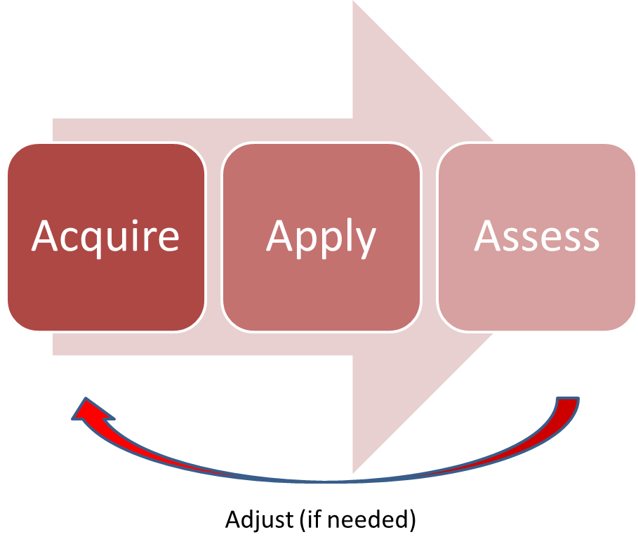

All Social Science Lessons should be designed around the triple A model. Teachers can choose how they do this either in lessons (Acquire, Apply, Assess) or through lesson and homework tasks (Acquire in lessons, apply, assess as homework). This ensures regular testing to check student learning and progress. It is essential we give students lots of opportunities for ‘hard thinking time’. There are elements within every lesson that will incorporate acquire, apply and assess. For example, in every social science lesson the starter activity is a connect 4 activity where student need to retrieve prior learning (what they learned last lessons, last week, last month, last year) so assess work is embedded into every lesson. Students will also have an oracy task in every lesson which will target the apply element of this model. Can students articulate their response to questions verbally using key subject specific terminology?

**Class Books – KS4**

Class books should be used for notes and task work. This is where formative assessment of student learning takes place. The same marking and feedback policy (as above) stands for class books. All tasks in book must be marked by either self (with teacher guidance), peers (with teacher guidance) or the class teacher.

All class books must have the **subject specific command words on the first inside page** and students should keep a **glossary of key terms at the back** of their books. Students should add to this this every time they are introduced to a new key term and teachers should follow the **golden triangle** when doing so – **definition, pronunciation, recognition**. All Social Science teachers should encourage students to learn key terms and use them in their verbal and written responses. High expectations of literacy at all times evident in books, assignments and lessons.

Teachers must ensure clear expectations around presentation and quality of work and ensure students take pride in their work, book and folder.

* Title and date (underlined with a ruler)
* Show high expectations of quality of written work
* Teacher should encourage proof reading of work and allow time for this
* Student checking for SPAG as well as teacher – evident in marking and feedback
* Use of academic language encourage consistently.

**KS5 – Notes/Assessment Folder**

At KS5 students are responsible for their own notes but each have an assessment folder where their summative assessments are stored. At the back of their folders there is a tracking document so students can track their own progress over time. Further evidence of progress/feedback can be found on google classroom with their assignment feedback.

**Teaching Pack**

By end of week 1 all Social Science staff must have a teaching pack completed for their classes and this should be easily accessible of the teacher’s desk. This should be a working document and used to help plan lessons to cater for the needs of all students in the class. Evidence of gain plan actions should be found in students’ books and assignments set on classroom. Use of departmental scaffold documents should be evidenced and signs that the scaffolds are slowly being removed to provide elements of challenge at a pace that is right for students.

**Curriculum/LTPs**

Your Long-term plans should reflect the journey the students are on in your course and there should be a rational for the sequencing of your LTP.

Alongside your LTP there should be curriculum plans for each topic which shows your medium-term planning – this should be kept in your teaching pack and annotated to show changes based on student pace and learning.

**Trackers**

Within your subject folder on the shared area there should be a folder for 2022-23 trackers where your trackers should be kept. Trackers must be detailed showing all summative assessments, dates, mark out of, % and grades (indicate grade boundaries used) and colour coded against target grade.

**Gain Plans**

Gain plans must be updated every data cycle to show reflection and adaptations to the interventions you have in place for each student. If a student has made no progress from one data cycle to the next a different intervention strategy should be used. Gain plans should be stored in the departmental shared area.

# Literacy

**Tier 1**: Basic familiar words commonly used by most students

**Tier 2**: Robust, high frequency words that students encounter across the content area and topics – often have multiple meanings. Command words.

**Tier 3:** Low frequency words that are content specific

Tier 1, 2 and 3 words will be displayed in each classroom and planning should reflect how teachers are integrating the words into their lessons and delivery to enhance student’s vocabulary.

**Glossary of key terms**

At KS4 we are introducing a glossary of key terms at the back of class books. Each time a new word is introduced to the students they add the word and definition to their glossary. Teacher should deliver using the golden triangle – definition, pronunciation, recognition.

**Command Words**

Command words can be found at the front of student books – when students are confronted with an exam question they should use their command work sheet to ensure they fully understand what the question in this subject is asking them. This should be link to the assessment objectives in the subject. For example, students in psychology should know that describe = A01 and evaluate = A03 as this will help them to understand how to structure their responses to exam questions to secure the highest available marks.

**Quality of written responses:**

* High expectations
* Students encourage to proof read their work
* Students and teachers check SPAG
* Use of academic language in written responses (teacher highlighting to student improved subject specific replacement words).

**Reading/Film Posters**

Students in social science subjects are encouraged to engage in wider reading to allow them to understand with wider aspects of the subjects they are studying or if there is something specific a student is interested in learning more about they have the opportunity to learn more about the topic. This allows for ‘reading for betterment’ (literacy policy).

**Social Science Little Library**

We have created a social science little library where students have the opportunity to take a book home to read that will expand and enhance their knowledge of key aspects of the subject they are studying. This follows a bring a book, take a book approach.

**Classroom Talk**

In every KS4 and 5 lessons students have a **connect 4** starter activity which will help them grapple with key terms and revisit them regularly to embed learning and understanding. Students will also have an **oracy task** every lesson encourage them to articulate high quality verbal responses using subject specific terminology.

# Resources

It is the student’s responsibility to continually check Google Classroom account as this is where all lesson resources will be posted and is where the teacher will communicate with the class. All revision material and revision websites will be posted on Google Classroom. These are the books we use in class:

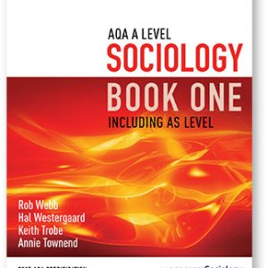 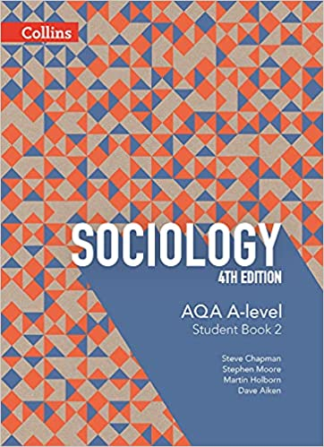

# Subject

|  |  |
| --- | --- |
| **Families Image result for the simpsons** | You will cover key topics such as: Changing patterns of marriage, cohabitation, separation, divorce, childbearing and the life course, including the sociology of personal life, and the diversity of contemporary family and household structures, gender roles, domestic labour and power relationships within the family in contemporary society and the nature of childhood, and changes in the status of children in the family and society. |
| **Education Image result for education** | You will cover key topics such as: The role and functions of the education system, including its relationship to the economy and to class structure, differential educational achievement of social groups by social class, gender and ethnicity in contemporary society and relationships and processes within schools, with particular reference to teacher/pupil relationships. |
| **Crime and Deviance Image result for crime and deviance** | You will cover key topics such as: The social distribution of crime and deviance by ethnicity, gender and social class, including recent patterns and trends in crime, globalisation and crime in contemporary society; the media and crime; green crime; human rights and state crimes • crime control, surveillance, prevention and punishment, victims, and the role of the criminal justice system and other agencies. |
| **Theory and methods** | You will cover key topics such as: Quantitative and qualitative methods of research; research design, sources of data, positivism, interpretivism and sociological methods; the nature of ‘social facts’, the theoretical, practical and ethical considerations influencing choice of topic, choice of method(s) and the conduct of research, consensus, conflict, structural and social action theories and the concepts of modernity and post-modernity in relation to sociological theory. |
| **Stratification and differentiation**  **Journalism and Communication.: Characteristics of Social Stratification** | You will cover key topics such as: stratification and differentiation by social class, gender, ethnicity and age. dimensions of inequality: class, status and power; differences in life-chances by social class, gender, ethnicity, age and disability. the problems of defining and measuring social class; occupation, gender and social class. changes in structures of inequality, including globalisation and the transnational capitalist class, and the implications of these changes. the nature, extent and significance of patterns of social mobility |

**A-level**

**Subject content**

**Compulsory content**

Education with Theory and Methods

1. Education
2. Methods in Context
3. Theory and Methods

Crime and Deviance with Theory and Methods

1. Crime and Deviance
2. Theory and Methods

**Optional**

Topics in Sociology

**Option 1**

1. Culture and Identity
2. Families and Households
3. Health
4. Work, Poverty and Welfare

**Option 2**

1. Beliefs in Society
2. Global Development
3. The Media
4. Stratification and Differentiation

# Syllabus

AQA

# What Will I Learn?

**Year 1: September-December**

**Education with Theory and Methods**

The study of the topics in this paper should engage students in theoretical debate while encouraging an active involvement with the research process.

The study should foster a critical awareness of contemporary social processes and change, and draw together the knowledge, understanding and skills learnt in different aspects of the course.

In their study of the topics, students should examine:

* topic areas in relation to the two core themes (socialisation, culture and identity; and social differentiation, power and stratification)
* both the evidence of and the sociological explanations for the content listed in the topic areas below.

Throughout, students should be encouraged to use examples drawn from their own experience of small-scale research.

Attention should be given to drawing out links with other topics studied in this specification.

**Education**

Students are expected to be familiar with sociological explanations of the following content:

* the role and functions of the education system, including its relationship to the economy and to class structure
* differential educational achievement of social groups by social class, gender and ethnicity in contemporary society
* relationships and processes within schools, with particular reference to teacher/pupil relationships, pupil identities and subcultures, the hidden curriculum, and the organisation of teaching and learning
* the significance of educational policies, including policies of selection, marketisation and privatisation, and policies to achieve greater equality of opportunity or outcome, for an understanding of the structure, role, impact and experience of and access to education; the impact of globalisation on educational policy.

**Methods in Context**

Students must be able to apply sociological research methods to the study of education

**Methods**

Students must examine the following areas:

* quantitative and qualitative methods of research; research design
* sources of data, including questionnaires, interviews, participant and non-participant observation, experiments, documents and official statistics
* the distinction between primary and secondary data, and between quantitative and qualitative data
* the relationship between positivism, interpretivism and sociological methods; the nature of ‘social facts’
* the theoretical, practical and ethical considerations influencing choice of topic, choice of method(s) and the conduct of research
* consensus, conflict, structural and social action theories

**Year 1: January-March**

**Families and Households** (Paper 2- Optional Units)

Students are expected to be familiar with sociological explanations of the following content:

* the relationship of the family to the social structure and social change, with particular reference to the economy and to state policies
* changing patterns of marriage, cohabitation, separation, divorce, childbearing and the life course, including the sociology of personal life, and the diversity of contemporary family and household structures
* gender roles, domestic labour and power relationships within the family in contemporary society
* the nature of childhood, and changes in the status of children in the family and society
* demographic trends in the United Kingdom since 1900: birth rates, death rates, family size, life expectancy, ageing population, and migration and globalisation.

**Year 1: April-June**

**Theory and Methods**

***Students must recap the following areas from year 1:***

* *quantitative and qualitative methods of research; research design*
* *sources of data, including questionnaires, interviews, participant and non-participant observation, experiments, documents and official statistics*
* *the distinction between primary and secondary data, and between quantitative and qualitative data*
* *the relationship between positivism, interpretivism and sociological methods; the nature of ‘social facts’*
* *the theoretical, practical and ethical considerations influencing choice of topic, choice of method(s) and the conduct of research*
* *consensus, conflict, structural and social action theories*

**Students must examine the following areas:**

* the concepts of modernity and post-modernity in relation to sociological theory
* the nature of science and the extent to which Sociology can be regarded as scientific
* the relationship between theory and methods
* debates about subjectivity, objectivity and value freedom
* the relationship between Sociology and social policy.

**Year 1 June-July**

Students to revisit material from Paper 1 and Paper 2 prior to moving into year 13 and paper 3.

**Year 2: September – November**

**Social Stratification and differentiation** (Paper 2- Optional Unit)

Students are expected to be familiar with sociological explanations of the following content:

• stratification and differentiation by social class, gender, ethnicity and age

• dimensions of inequality: class, status and power; differences in life-chances by social class, gender, ethnicity, age and disability

• the problems of defining and measuring social class; occupation, gender and social class

• changes in structures of inequality, including globalisation and the transnational capitalist class, and the implications of these changes

• the nature, extent and significance of patterns of social mobility.

**Year 2 – November – February**

**Crime and Deviance with Theory and Methods**

The study of the topics in this paper should engage students in theoretical debate while encouraging an active involvement with the research process.

The study should foster a critical awareness of contemporary social processes and change, and draw together the knowledge, understanding and skills learnt in different aspects of the course.

In their study of this topic, students should examine:

* topic areas in relation to the two core themes (socialisation, culture and identity; and social differentiation, power and stratification)
* both the evidence of and the sociological explanations for the content listed in the topic areas below.

Throughout, students should be encouraged to use examples drawn from their own experience of small-scale research.

Attention should be given to drawing out links with other topics studied in this specification.

**Crime and Deviance**

Students are expected to be familiar with sociological explanations of the following content:

* crime, deviance, social order and social control
* the social distribution of crime and deviance by ethnicity, gender and social class, including recent patterns and trends in crime
* globalisation and crime in contemporary society; the media and crime; green crime; human rights and state crimes
* crime control, surveillance, prevention and punishment, victims, and the role of the criminal justice system and other agencies.

**Year 2 February -May**

Students will engage in a 3 month structured recap and revision schedule in lesson and remotely covering content from paper 1, 2 and 3.

# How Will I Be Assessed?

At A-level there are three exams, each account for one third of your A-level grade. The three exams last 2 hours and are worth 80 marks each. The exams consist of a mixture of short answer and extended writing questions.

|  |  |  |  |
| --- | --- | --- | --- |
| **Paper** | **Topic** | **Marks per section** | **Total Marks** |
| **Paper 1**  **Education with**  **Theory and Methods** | Education: short answer  and extended writing | 50  marks |  |
|  | Methods in Context:  extended writing | 20 marks |  |
|  | Theory and Methods:  extended writing, | 10 marks |  |
|  |  |  | **2 hour written exam**  **80 marks**  **33.3% of A Level** |

|  |  |  |  |
| --- | --- | --- | --- |
| **Paper** | **Topic** | **Marks per section** | **Total Marks** |
| **Paper 2**  **Topics in Sociology** | Section A: extended writing – Families | 40 marks |  |
|  | Section B: extended writing – Social Stratification and differentiation | 40 marks | **2 hour written exam**  **80 marks**  **33.3% of A Level** |

|  |  |  |  |
| --- | --- | --- | --- |
| **Paper** | **Topic** | **Marks per section** | **Total Marks** |
| **Paper 3**  **Crime and**  **Deviance with Theory and**  **Methods** | Crime and Deviance: short  answer and extended writing | 50 marks |  |
|  | Theory and Methods:  extended writing | 30 marks | **2 hour written exam**  **80 marks**  **33.3% of A Level** |

**Year 1:**

* **Paper 1 and Paper 2 Mock Examination: June 2021 – End of topic tests for each topic –** Each time you complete a topic you will receive an assessment on that topic. You must be achieving a D+ in these assessments minimum in year 1 and a C+ minimum is year 2. Your results will also be carefully tracked against your target grade.

**Year 2:**

* **End of topic tests for each topic –** Each time you complete a topic you will receive an assessment on that topic. You must be achieving a D+ in these assessments minimum in year 1 and a C+ minimum is year 2. Your results will also be carefully tracked against your target grade.
* **Paper 1 and Paper 2 Mock Examination: November 2021**
* **Paper 1, 2 and 3 Mock Examination: February 2022**

**Year 1:**

* **Paper 1 PPE January: Paper 1 and Paper 2 PPE: June**
* **End of topic tests for each topic –** Each time you complete a topic you will receive a 48 mark assessment on that topic – this may also contain research methods questions and questions from topics previously covered. You must be achieving a D+ in these assessments minimum in year 1 and a C+ minimum is year 2. Your results will also be carefully tracked against your target grade. Those achieving less than minimum expectation will have a resit opportunity and be placed on an Actions to Achieve to monitor improvement/progress closely.

**Year 2:**

* **End of topic tests for each topic –** Each time you complete a topic you will receive a 48 mark assessment on that topic – this may also contain research methods questions and questions from topics previously covered. You must be achieving a D+ in these assessments minimum in year 1 and a C+ minimum is year 2. Your results will also be carefully tracked against your target grade. Those achieving less than minimum expectation will have a resit opportunity and be placed on an Actions to Achieve to monitor improvement/progress closely.
* **Paper 1 and Paper 2 PPE: November**
* **Paper 1, 2 and 3 PPE: February**

**Assessment objectives**

Assessment objectives (AOs) are set by Ofqual and are the same across all AS and A-level Psychology specifications and all exam boards.

The exams will measure how students have achieved the following assessment objectives.

**AO1**: Demonstrate knowledge and understanding of scientific ideas, processes, techniques and procedures.

**AO2:** Apply knowledge and understanding of scientific ideas, processes, techniques and procedures:

* in a theoretical context
* in a practical context
* when handling qualitative data
* when handling quantitative data.

**AO3**: Analyse, interpret and evaluate scientific information, ideas and evidence, including in relation to issues, to:

# How Will This Prepare Me For My Next Steps?

A Level Sociology is the study of society, patterns of social relationships, social interaction and culture of everyday life and this qualification prepares students for their next steps after A Levels in a number of different ways. It is a social science that uses various methods of empirical investigation and critical analysis to develop a body of knowledge about social disorder, acceptance, and change of social evolution. Students develop their analytical thinking and learn how research can be evaluated highlighting the strengths and limitations. The study of research methods provides students with a good foundation that will support their studies at degree Level, not only in sociology, but in a number of different subject areas. Many of the topics taught at A Level are also found at degree level, therefore provides A Level students with the foundation knowledge and skills needed to go on and study the subject in more depth at degree Level and beyond.

# Contribution to UTC & Studio Aims

Throughout the A Level course students will have opportunities to attend trips where they can enhance their learning experience and see psychology in the real world and the impact the subject has had and can have in the future. Our annual Auschwitz trip allows students to the opportunity to understand the impact of social influence on global societies much more effectively than they could do in the classroom. Students also have the opportunity to hear from industry experts in our masterclass events. There are so many branches of sociology we feel it is important for our students to understand as many branches as possible to guide them towards careers they may be interested in entering into in the future. This includes talks from social workers, police officers, lawyers and journalists.

# Career Planning

Studying sociology can give you a whole host of exciting career options including:

• Social work

• Human resources

• Advertising

• Policing

• Marketing

• Journalism

• Law

• Teaching