**BTEC Level 3**

**Extended Certificate**

**Enterprise and Entrepreneurship**



Tutor

Sam Forrest

Email: [s.forrest@thestudio-liverpool.co.uk](mailto:s.forrest@thestudio-liverpool.co.uk)

**Pearson BTEC Level 3 Extended Certificate in Enterprise and Entrepreneurship**

The BTEC National Extended Certificate in Enterprise and Entrepreneurship is made up of 4 units of which 2 are assessed by and exam and 2 by internal course work.

The Extended Certificate is designed to be the substantive part of a 16–19 study programme for learners who want a strong core of sector study.

BTEC grades range from a pass up to a distinction and these grades convert into UCAS points for those wishing to study at university.

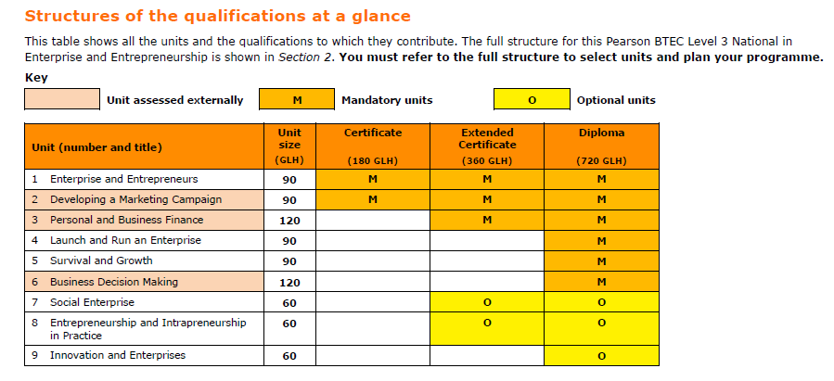

**Unit 1: Enterprise and Entrepreneurs**

Level: **3**

Unit type: **Internal**

Guided learning hours: **90**

**Unit in brief**

Learners study enterprise and the mind-set of entrepreneurs, exploring the risks, opportunities and constraints of starting an enterprise.

**Unit introduction**

Enterprise is important because it is the creation of new ventures that drive the economy, employment, growth and innovation across the UK. Entrepreneurs are those who take that first brave step, identify an opportunity and start their own enterprise. They have a clear vision and the determination to put their ideas into practice. We can all name a famous entrepreneur, but what is it that makes them so successful? What are the personal skills, qualities and characteristics that make them unique? Which attributes do they have that allow them to plan and run their enterprise?

In this unit, you will gain an overview of the importance of both enterprise and entrepreneurs to the local and national economy. You will explore their creativity and mind-set as you look at real-life enterprise and entrepreneurs, and investigate the skills required to be successful. You will also look at the risks, opportunities and constraints faced by entrepreneurs in setting up their venture, assess the feasibility of a range of potential enterprise opportunities and then develop and present one idea for a local enterprise.

This unit will help you progress to employment by helping to develop key employability skills, or to vocational training, higher apprenticeships or higher education by developing relevant knowledge and understanding.

**Learning aims**

In this unit you will:

**A** Explore the nature of enterprise

**B** Investigate the motivations for entrepreneurship

**C** Examine the opportunities and constraints for enterprises and entrepreneurs

**D** Examine the entrepreneurial skills required to launch an enterprise

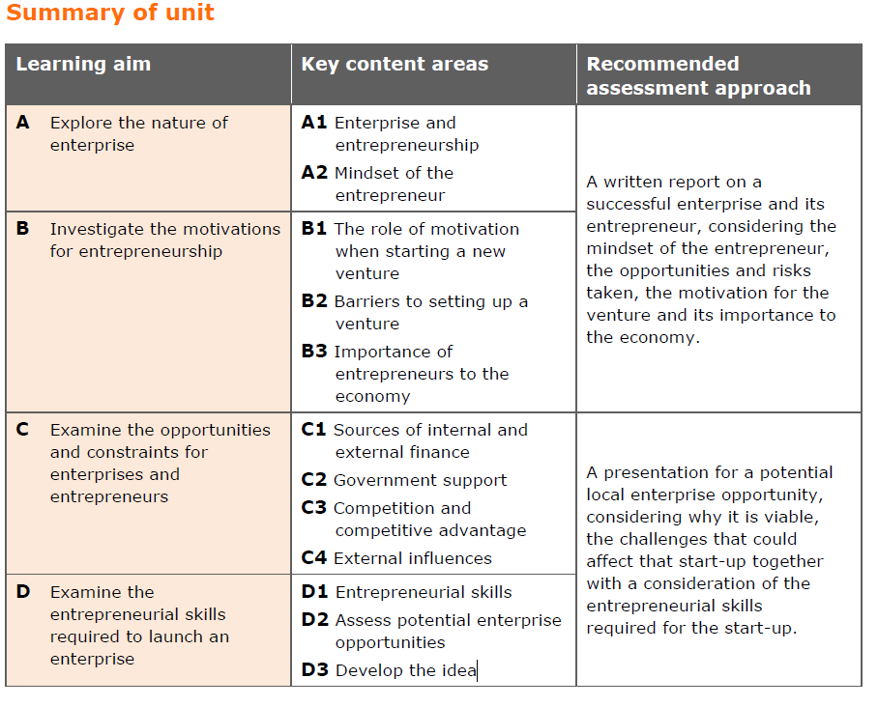

**Unit 2: Developing a Marketing Campaign**

Level: **3**

Unit type: **External**

Guided learning hours: **90**

**Unit in brief**

Learners will gain skills relating to, and an understanding of, how a marketing campaign is developed.

**Unit introduction**

Marketing is a dynamic field central to the success of any business. You will gain an understanding of how a marketing campaign is developed. You will explore different stages of the process that a business goes through when developing its campaign and develop your own campaign for a given product/service.

You will examine the marketing aims and objectives for existing products/services and understand the importance of relevant, valid and appropriate research in relation to customers’ needs and wants. You will use given market research data and other information to make recommendations about the type of marketing campaign that a business should undertake. In this unit, you will draw on your learning from across your programme to complete the assessment task.

This unit will give you an insight into how important marketing is to business. It will enable you to make an informed choice as to whether you want to specialise in marketing in employment, training or higher education.

**Summary of assessment**

This unit is assessed under supervised conditions. Learners will be given a case study two weeks before a supervised assessment period in order to carry out research. The supervised assessment period is a maximum of three hours and can be arranged over a number of sessions. During the supervised assessment period, learners will be required to complete

a task where they prepare a rationale and then a plan for a marketing campaign for a given product or service. Pearson sets and marks the task.

The number of marks for the unit is 70.

The assessment availability is twice a year in January and May/June.

**Assessment outcomes**

**AO1** Demonstrate knowledge and understanding of marketing principles, concepts, processes, key terms, data sources and definitions

**AO2** Analyse marketing information and data, demonstrating the ability to interpret the potential impact and influence on marketing campaigns

**AO3** Evaluate evidence to make informed judgements about how a marketing campaign should be planned, developed and adapted in light of changing circumstances

**AO4** Be able to develop a marketing campaign with appropriate justification, synthesising ideas and evidence from several sources to support arguments

.

**Unit 3: Personal and Business Finance**

Level: **3**

Unit type: **External**

Guided learning hours: **120**

**Unit in brief**

Learners study the purpose and importance of personal and business finance. They will develop the skills and knowledge needed to understand, analyse and prepare financial information.

**Unit introduction**

This unit includes aspects of both personal and business finance. Personal finance involves the understanding of why money is important and how managing your money can help prevent future financial difficulties. It is vital you understand the financial decisions you will need to take throughout your life and how risk can affect you and your choices. This unit will also give you an insight into where you can get financial advice and support.

The business finance aspects of the unit introduce you to accounting terminology, the purpose and importance of business accounts and the different sources of finance available to businesses.

Planning tools, such as cash flow forecasts and break-even, will be prepared and analysed.

Measuring the financial performance of a business will require you to prepare and analyse statements of comprehensive income and statements of financial position.

This unit will provide a foundation for a number of other finance and business units and will help you to analyse profitability, liquidity and business efficiency. It will give you the knowledge and understanding to manage your personal finances and will give you a background to business finance and accounting as you progress to employment or further training.

**Summary of assessment**

This unit is assessed by a written examination set by Pearson.

The examination will be two hours in length.

The number of marks for the examination is 80. (Section A contains questions on the personal finance unit content and approximately one-third of the marks, and Section B contains questions on the business finance unit content and approximately two-thirds of the marks).

The assessment availability is twice a year in January and May/June.

**Assessment outcomes**

**AO1** Demonstrate knowledge and understanding of business and personal finance principles, concepts, key terms, functions and theories.

Command words: describe, explain, give, identify, outline

Marks: ranges from 1 to 4 marks

**AO2** Apply knowledge and understanding of financial issues and accounting processes to real-life business and personal scenarios

Command words: analyse, assess, calculate, describe, discuss, evaluate, explain

Marks: ranges from 2 to 12 marks

**AO3** Analyse business and personal financial information and data, demonstrating the ability to interpret the potential impact and outcome in context

Command words: analyse, assess, discuss, evaluate

Marks: ranges from 6 to 12 marks

**AO4** Evaluate how financial information and data can be used, and interrelate, in order to justify conclusions related to business and personal finance

Command words: analyse, assess, discuss, evaluate

Marks: ranges from 6 to 12 marks

**Unit 7: Social Enterprise**

Level: **3**

Unit type: **Internal**

Guided learning hours: **60**

**Unit in brief**

Learners research and develop an understanding of organisations trading for social purposes, gaining practical experience in planning and running a short social enterprise activity.

**Unit introduction**

You might not think you know anything about social enterprise – but you have probably bought a copy of the Big Issue, shopped at the Co-op, donated through JustGiving and heard about the Eden Project and Jamie Oliver’s Fifteen. Social enterprise is any organisation that has primarily social objectives or a social moral purpose, for example tackling social problems, improving communities and people’s life chances, or the environment. Rather than maximising profit for shareholders and owners, social enterprises have a different purpose as they reinvest the profits/surpluses made back into the organisation and into the community. Social enterprises are sometimes referred to as having a ‘double bottom line’ as their objective is achieving targets that are both social and financial.

In this unit, you will learn about social enterprise, an ethos that is growing around the globe and is gaining support from the public, private and voluntary sectors. The national body for social enterprise, Social Enterprise UK, has described Britain as being on the frontline of social enterprise activity compared with the rest of the world. Social enterprises compete in the marketplace and need to be well run to make money and achieve their social aims. They can vary from small community-owned village shops to large organisations delivering public services. You will explore what it is that makes them a success or a failure and will then engage in running a short social enterprise of your choice.

This unit will help you to progress to employment through developing key employability skills, and to vocational training and higher apprenticeships or higher education by developing relevant knowledge and understanding.

**Learning aims**

In this unit you will:

**A** Investigate a range of social enterprises

**B** Explore the factors that contribute to the success or failure of social enterprises

**C** Plan, participate in and review a short social enterprise activity.

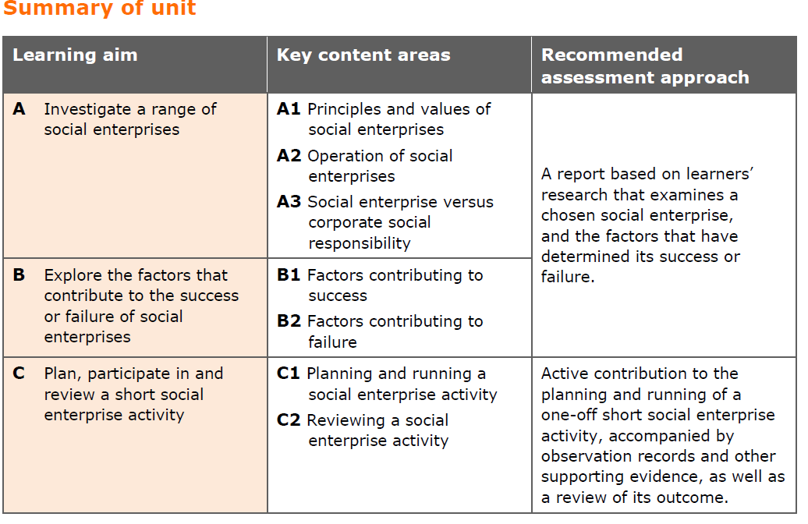

# **Literacy**

Throughout this course of study there are ample opportunities for pupils to develop their literacy skills. The nature of Business and Enterprise warrants itself to such skills. Examples of literacy development include:

* development of complex paragraphs
* key words highlighted for each lesson and emphasis placed on the use of words in writing activities
* reading material which includes topical issues and current business case studies
* cross-referencing of sources
* analysis of interpretations
* evaluation of sources

**Exam Board**

The awarding body for this qualification is **Pearson Edexcel**

**Entry requirements:**

GCSE: At least 4, graded 8-4 including English and Maths and/or BTEC: BTEC Level 2 Diploma Business at Merit or Distinction Level (or related subject)

**What characteristics and skills do you need to be successful?**

* Excellent numeracy and communication skills
* Committed
* Motivated
* Enthusiastic
* Positive
* Polite
* Respectful
* Willingness to embrace new experiences

**Why should I do this course?**

If you are interested in starting your own business enterprise or developing a career with any commercial organisation of any size, or if you wish to progress to a suitable higher education course.

**How will my work be assessed?**

Unit 01 and Unit 07 are assessed by coursework ( 2 assignments each).

Unit 02 and 03 are assessed by external exams

**What can I do after this?**

Students who complete this Level 3 qualification can progress to further study at University, continue to run and expand their business. Graduates from the programme have a broad range of opportunities for employment within different industries where they can apply their business skills.

**Progression Routes**

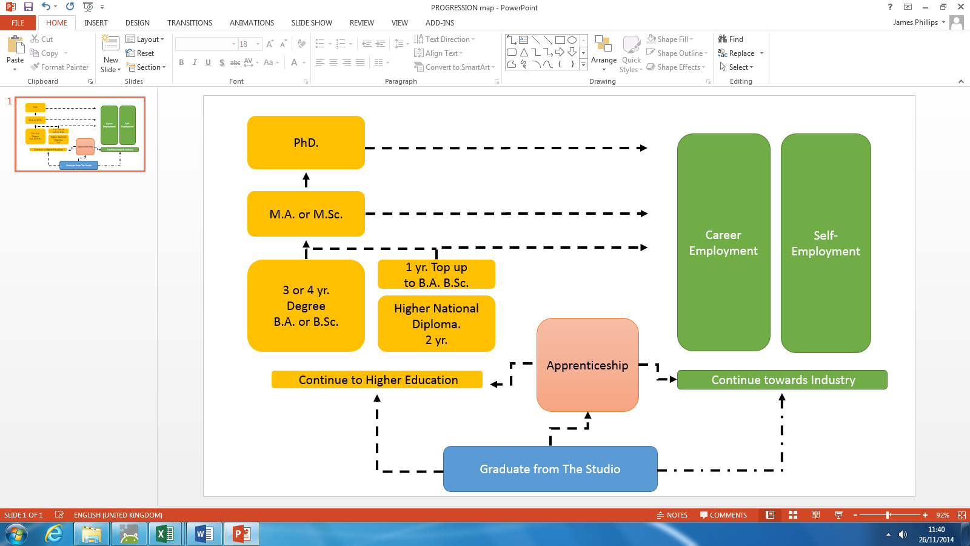

**Industry Links:**  
The Studio has excellent links with a number of local Industry partners and a number of our students carry out internships and work placements with these companies during their studies. These internships are supported by the school through networking meetings where students can pitch their skill set and requirements directly to the companies.

**Apprenticeship Schemes:** [*www.bbc.co.uk/careers/trainee-schemes*](http://www.bbc.co.uk/careers/trainee-schemes)

[*http://www.thebigchoice.com/*](http://www.thebigchoice.com/)

[*http://www.itvjobs.com/working-here/apprenticeships/*](http://www.itvjobs.com/working-here/apprenticeships/)

[*http://mediacom.co.uk/en/careers/mediacom-apprentices.aspx*](http://mediacom.co.uk/en/careers/mediacom-apprentices.aspx)

**Potential careers and example salaries**

Entrepreneur - £50,000 +

Marketer -£35,000 +

Finance Manager - £30,000 +

Operations Manager - £30,000 +

**Deadlines**

If submitting on paper, you must also hand in the front sheet and this sheet from this assignment, signed to state that this is your own work, (a learner declaration sheet). Any other accompanying paperwork should be stapled to the front sheet or collected in a plastic/paper wallet and/or folder. Your name should appear on all documents.

Electronic submission of work from a logged-in school email account is counted as a declaration that it is all your unaided work, or the upload to Google Classroom. All computer files relating to this assignment must be stored on the college network.

**The Studio provides the resources needed to complete work on time.   
Problems with other computer systems are never acceptable as a reason for late work.**

**Re-submission Policy**

Only the Lead Internal Verifier can authorise a re-submission and application for resubmission must be negotiated through your assessor. In order to qualify for potential re-submission you must meet the following criteria:

* The learner has met initial deadlines or agreed deadline extension.
* The tutor judges that the learner will be able to provide improved evidence without further guidance.
* The assessor has authenticated the evidence submitted for assessment and evidence is accompanied by a signed-and-dated declaration of authenticity by the learner.   
    
  If any of these conditions are not met then re-submission cannot be authorised.

**The resubmission process requires you to provide your re-submitted evidence within 10 academic days from approval.**

**Re-Take**

Should you need to retake a second assignment brief will be given to you to complete. You will be able to achieve no higher than a **PASS** for this assignment.   
If you fail the second assignment then further action will be taken.

**Types of evidence accepted**

All work submitted will be considered for assessment. Include everything with your submission as it may help describe, explain or justify your work. Reference and cite any work included that is not yours as well as providing a bibliography and/or research log to demonstrate where you have found the information. Any work that is submitted that cannot be marked will be put forward as supporting evidence.

**BTEC Grading Systems**

Each unit has a number of Pass, Merit and Distinction criteria linked to Learning Outcomes (LO). You will find reference to these in the form of e.g. P1 M1 D1.

Each LO must be reach a minimum of pass, to pass the unit and in order to gain a Unit (P, M or D) grade you must get all Learning Outcomes to be of an equal grade.

|  |  |  |  |
| --- | --- | --- | --- |
|  |  |  | Overall Unit Grade |
| P | P | P | P |
| M | M | M | M |
| D | D | D | D |

Any variation of grade will result in the lowest grade being the overall unit grade e.g.

|  |  |  |  |
| --- | --- | --- | --- |
|  |  |  | Overall Unit Grade |
| D | D | P | P |
| D | M | D | M |
| P | M | D | P |
| M | D | M | M |
| M | M | P | P |

Your final unit grades will be recorded on the tracking spreadsheet and will result in a number of BTEC points. The BTEC points are then converted into a final grade(s) and have an equivalent number of UCAS points. (See UCAS tariff points table).

**Grade Calculator**

[**https://qualifications.pearson.com/en/support/support-topics/results-certification/understanding-marks-and-grades/using-the-next-generation-btec-nqf-grade-calculator.html**](https://qualifications.pearson.com/en/support/support-topics/results-certification/understanding-marks-and-grades/using-the-next-generation-btec-nqf-grade-calculator.html)

|  |  |  |
| --- | --- | --- |
| **New Tariff points** | **BTEC Diploma** | **BTEC Extended Certificate** |
| **168** |  |  |
| **160** |  |  |
| **152** |  |  |
| **144** |  |  |
| **128** |  |  |
| **112** | **D*D\*** |  |
| **104** | **D*D** |  |
| **96** | **DD** |  |
| **80** | **DM** |  |
| **64** | **MM** |  |
| **56** |  | **D\*** |
| **48** | **MP** | **D** |
| **40** |  |  |
| **32** | **PP** | **M** |
| **28** |  |  |
| **24** |  |  |
| **20** |  |  |
| **16** |  | **P** |
| **12** |  |  |
| **10** |  |  |
| **8** |  |  |
| **6** |  |  |

**UCAS tariff points**

BTEC have also introduced a **Near Pass** (NP) system for external exams that allows the candidate to pass the overall qualification based on the accumulation of marks from the internal assessments and both exams.

# **Contribution to UTC & Studio Aims**

**The Studio:**

“Our purpose is to prepare you for success in a fast-moving digital world and, in particular, help create opportunities to work or launch businesses in the creative and digital industries. We’ve created an environment to inspire creativity and critical thinking, fed by the industry knowledge of our partners, that lead the sector across the region.”[1]

**Life Sciences UTC:**

“Our ethos is simple: we’re committed to providing the highest standards of teaching and learning, combined with real life industry experience which opens doors for our students. Our offer is unique, and we’re proud to work with some of the world-leaders in science and healthcare, giving our students the ability to build a strong and enviable portfolio of experience, so they can hit the ground running once they graduate from our UTC.”[2]

The teaching of Enterprise and Entrepreneurship supports the ethos that the students will develop skills in order to become independent and confident people in the working community.

1. <https://thestudioliverpool.uk/who-we-are/about-us-and-ethos-2/>
2. <https://lifesciencesutc.co.uk/who-we-are/about-us-and-ethos/>