Planning for Learning

Health & Social Care – Key Stage 5

C Perischine

Life Sciences UTC  [Company address]

Table of Contents

1.Sequencing Statement 1

2.Specialism Statement 1

3.Curriculum on a Page 1

4.Knowledge Acquisition 2

5.Routines 2

6.Literacy 3

7.Resources 4

8.Subject (KS5) 5

9.Syllabus 6

10.What Will I Learn? 7

11.How Will I Be Assessed? 10

12.How Will This Prepare Me for My Next Steps? 11

13.Contribution to UTC & Studio Aims 12

14.Career Planning 13

# 1. Sequencing Statement

Our intention, in the Health Sciences Department is to give students the opportunity to explore new and unfamiliar concepts of Health Sciences in an effort to broaden knowledge and understanding in relation to the skills and knowledge required to pursue a successful career in the Health Sciences industry. Units have been selected to provide learners with a foundation on which to build an understanding of the roles and responsibilities of health care professionals in addition to providing ample opportunity to develop the skills required for study at a higher academic level. Units of study will be varied to include academic topics such as Psychological Perspectives in Health & Social Care, Genetics and Scientific Techniques to more practical units such as Caring for Individuals with Dementia.

# 2. Specialism Statement

The Health Sciences department prides itself on being able to support the ethos of Life Sciences UTC through a variety of means. Firstly, our course provides opportunity to apply academic approaches to vocational scenarios preparing our students for both academic and vocational progression. The rigour of our internal assessment encourages a number of skills including development of literacy, critical thinking and workload management. In addition we have strong links with The Royal Liverpool Hospital Trust with whom we have developed our Cadet programme and are able to provide unique work experience opportunities for our learners that are currently unavailable elsewhere.

# 3. Curriculum on a Page

The Level 3 Extended Diploma in Health & Social Care – Health Sciences requires completion of thirteen units, four of which are externally assessed exams, nine units will be internally assessed assignments. All assessments both external and internal are graded Pass – Distinction.

The Units we will study at Lifesciences UTC are:

**Human Lifespan Development** – Exam Unit, Exam January of Year 12

**Working in Health & Social Care –** Exam Unit, Exam January of Year 12

**Anatomy & Physiology for HSC –** Exam Unit, Exam January of Year 13

**Enquiries into Current Research** – Exam Unit, Exam January of Year 13

**Meeting Individual Care & Support Needs –** Internal Assessment

**Work Experience in HSC –** Internal Assessment

**Principles of Safe Practice in HSC** – Internal Assessment

**Promoting Public Health –** Internal Assessment

**Psychological Perspectives for HSC –** Internal Assessment

**Caring for Individuals with Dementia –** Internal Assessment

**Nutritional Health** – Internal Assessment

**Scientific Techniques for Health Science** – Internal Assessment

**Genetics** – Internal Assessment

# 4. Knowledge Acquisition

The ability to see how the information that you taught fits together related to the ‘Key Question’ for each assessment criteria, in addition to how knowledge can be used from one unit to another, is significantly vital in the study of BTEC Health & Social Care.

In order to help you with your knowledge acquisition we have developed a variety of resources and techniques that will be used over the two years of study:

* Knowledge tests will play a role in your externally assessed units. You will be told in advance of when you will be given a knowledge test, in addition to the areas that it will be based upon
* Essays will give you an opportunity to develop your knowledge in relation to some of the externally assessed topics. You will be given essays to complete at home whereby you can develop a full answer to the question. You will also be given in-class essays to be completed under timed conditions – to replicate exam conditions. You will be told in advance of the in-class essays.
* Assessment preparation tasks related to internally assessed topics will be provided

# 5. Routines

Health Sciences is taught across fifteen lessons a week. The fifteen lessons are split between Ms Perischine, Miss Graham and …………. with each teacher taking five lessons each.

Ms Perischine teaches Human Lifespan Development, Meeting Individual Care & Support Needs, Work Experience in HSC, Psychological Perspectives & Caring for Individuals with Dementia

Miss Graham teaches Working in Health & Social Care, Enquiries into Current Research in HSC, Principles of Safe Practice in HSC & Promoting Public Health & Nutritional Health

Mr Gordon teaches Anatomy & Physiology, Nutritional Health, Scientific Techniques for Health Science and Genetics.

This means that you learn three topics simultaneously across the two years. The exam taught element is delivered in the Autumn Terms of Year 12 & Year 13 by both MS Perischine & Miss Graham. Coursework is ongoing but completion is expected by the end of the Spring term in year 13.

You will be assessed using predominately past paper questions and internal assessments. Feedback here will relate to the mark scheme provided by the awarding body and will relate to the level of analysis/evaluation that you have displayed.

# 6. Literacy

Throughout this course of study there are ample opportunities for pupils to develop their literacy skills. The nature of assignment writing as required for internal assessment warrants itself to such skills. Examples of literacy development include:

* development of complex paragraphs
* key words highlighted for each lesson and emphasis placed on the use of words in writing activities
* reading material which includes academic research in the subject area
* cross-referencing of sources
* evaluation of sources.

# 7. Resources

For Health Sciences, each of the subject teachers has their own Google classroom for the topics that they teach. The Google classroom is broken down into the units that make up that topic, alongside additional learning and support material relative to each topic – below there is an example of the Google classroom.

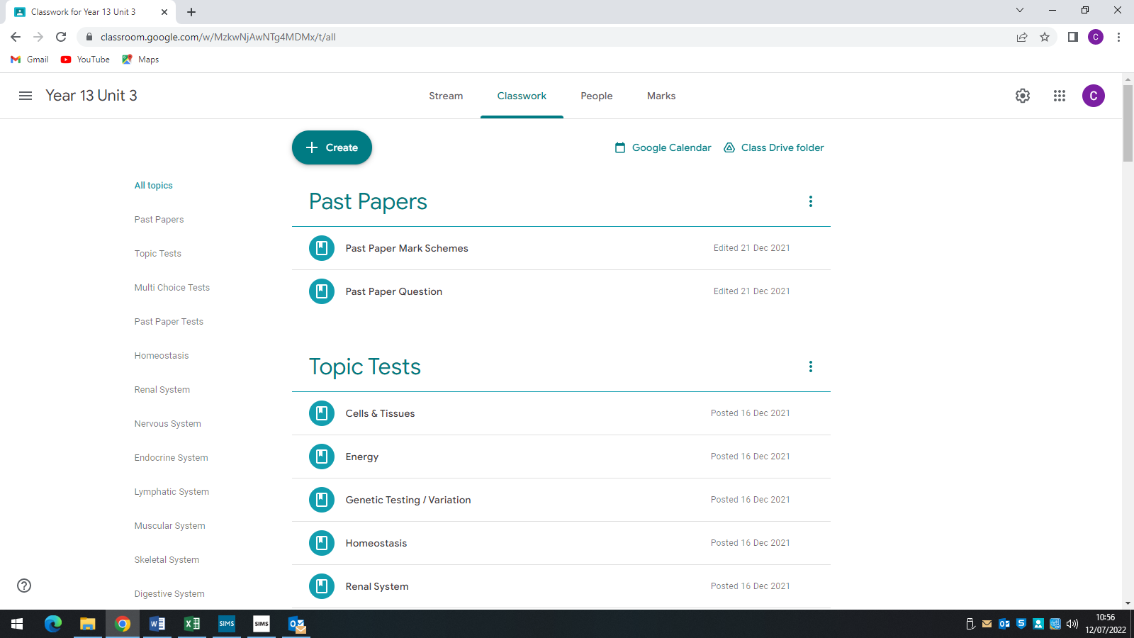

# 8. Subject (KS5)

BTEC Health & Social Care - Health Sciences is an opportunity for you to develop a set of skills that will prepare you well for university and the world of employment.

Specifically, each unit is broken down into a number of Learning Aims which are designed to ensure that each unit is examined in depth.

# 9. Syllabus

Health & Social Care we are following the Pearson BTEC Level 3 National Extended Diploma in Health & Social Care. We are completing qualification equivalent to 3 A Levels. Please follow this link for a detailed look at the specification:

https://qualifications.pearson.com/content/dam/pdf/BTEC-Nationals/Health-and-Social-Care/2016/specification-and-sample-assessments/9781446938034_BTEC_Nat_ExtDip_HSC_Spec_Iss3C.pdf

# 10. What Will I Learn?

Each of the units will examine the topics detailed below:

**Human Lifespan Development –** Human Growth & Development through the Life Stages; Factors Effecting Growth & Development, Effects of Ageing,

**Working in Health & Social Care –** Roles & Responsibilities of those Working in HSC; Roles of Organisations; Working with People with Specific Needs,

**Anatomy & Physiology for HSC –** Structure & Organisation of the Human Body; Structure, function & Disorders of body systems; Medical Research

**Enquiries into Current Research –** Types of Issues where Research is Carried Out; Research Methods; Carrying out & Reviewing Secondary Research

**Meeting Individual Care & Support Needs –** Principles, Values & Skills which underpin meeting the Care Needs of Individuals; Ethical Issues when Providing Care; Principles Involved in Enabling Service Users to Overcome Challenges; Roles of Professionals;

**Work Experience in HSC –** Benefits of Work Placement; Development of a Work Experience Plan; Carry Out Work Experience (100 Hours); Reflect on Work Experience

**Principles of Safe Practice in HSC –** Duty of Care; Recognising & Responding to abuse and neglect; Influence of Legislation and Policy; Procedures & Responsibilities for maintaining health & Safety

**Promoting Public Health –** Strategies for Developing Public Health Policy; Factors Effecting Health; How Health is Promoted; How Health Promotion Encourages Change

**Psychological Perspectives for HSC** – How Psychological Perspectives contribute to understanding Human Behaviour; Contribution of Perspectives in Management and Treatment of Specific Behaviours; How Perspectives are Applied in Care Settings.

**Caring for Individuals with Dementia –** Examine the Types, Causes and Symptoms of Dementia; Examine the Effects of Dementia on People who have the Condition; Investigate the concept of person Centred Care for People who have Dementia to maintain Quality of Life and Dignity

**Nutritional Health –** Understand Concepts of Nutritional Health & Characteristics of Essential Nutrients, Examine Factors Effecting Dietary Intake & Nutritional Health; Plan Nutrition to Improve Nutritional Health

**Scientific Techniques for Health Science –** Understand how a Health Related Laboratory deals with Samples sent for Analysis; Carry out Investigations using Techniques similar to those in a health related laboratory; Carry out Investigations using Light Microscopes similar to those in a health related laboratory

**Genetics –** Understand Genetics & its Role in Human Inheritance; Examine the Factors affecting Pre and Post Natal Development; Investigate how Advances in Science can Contribute to Understanding Reproductive & Gene Technologies; Examine How Legislation and Ethical Challenges influence the use Of Reproductive and Gene technologies

# 11. How Will I Be Assessed?

You will be assessed through a combination of Externally Assessed Examinations and Internally Assessed Assignments.

# 12. How Will This Prepare Me for My Next Steps?

BTEC Health & Social Care – Health Sciences has a focus on the holistic development on the practical, interpersonal and thinking skills required to be able to succeed in both employment and higher education. The content considers the needs of both employers and higher education providers therefore offering you the opportunity to develop a variety of skills that are applicable to a vast multitude of different areas of study. When creating your UCAS personal statement, or putting together a CV and preparing for a job interview, the skills outlined below will help you to formulate a clear overview of the way in which Health Sciences has prepared you for the next steps in your journey.

The abilities that Health Sciences will help you to develop include:

* critical reasoning and analytical skills, including the capacity for solving problems and thinking creatively
* intellectual rigour and independence, including the ability to conduct detailed research
* ability to construct an argument and communicate findings in a clear and persuasive manner, both orally and in writing
* ability to work without direct supervision and manage time and priorities effectively
* ability to discuss ideas in groups, and to negotiate, question and summarise
* capacity to think objectively and approach problems and new situations with an open mind
* appreciation of the different factors that influence the activities of groups and individuals in society.

# 13. Contribution to UTC & Studio Aims

**Life Sciences UTC:**

“Our ethos is simple: we’re committed to providing the highest standards of teaching and learning, combined with real life industry experience which opens doors for our students. Our offer is unique, and we’re proud to work with some of the world-leaders in science and healthcare, giving our students the ability to build a strong and enviable portfolio of experience, so they can hit the ground running once they graduate from our UTC.”[1]

The Health Sciences Department prides itself on being able to support the ethos of Life Sciences UTC through a variety of means. Firstly, our course provides opportunity for academic approach to be applied to vocational scenarios. In addition, we have strong links with a The Royal Liverpool Hospital providing excellent opportunity for real life experience in our city’s busiest hospital setting.

# 14. Career Planning

Typical employers of health graduates include Primary & Secondary Health Care providers although due to the range of academic knowledge, skill and practical skills developed our alumni have included Primary School Teaching, Cosmetic Pharmaceutical’s, and Public Service.

**Health & Social Care Undergraduate Courses:**

* Adult Nursing BSc (Hons)
* Childrens Nursing BSc (Hons)
* Mental Health Nursing BSc (Hons)
* Midwifery BSc (Hons)
* Nutrition (Exercise & Health) BSc (Hons)
* Social Work BA (Hons)

**Undergraduate Courses & Jobs where your Health & Social Care Level 3 would be relevant:**

* Primary School Teaching
* Youth Work
* Counselling
* Health Care Assistant
* Psychology BSc (Hons)
* Rehab Worker

1. <https://lifesciencesutc.co.uk/who-we-are/about-us-and-ethos/>